**From:** Jeanne Johnson <[jeannehopejohnson@gmail.com](mailto:jeannehopejohnson@gmail.com)>  
**Date:** May 2, 2017 at 10:17:17 AM EDT  
**To:** Daniel Hubbard <[daniel.hubbard@patch.com](mailto:daniel.hubbard@patch.com)>, [clevine@dailyvoice.com](mailto:clevine@dailyvoice.com), [georgethompson1491@gmail.com](mailto:georgethompson1491@gmail.com), Darren Cooper <[CooperD@NorthJersey.com](mailto:CooperD@NorthJersey.com)>, [sports@nj.com](mailto:sports@nj.com); Adam Brunner <[abrunner@ridgewood.k12.nj.us](mailto:abrunner@ridgewood.k12.nj.us)>

**Cc:** [genec189@gmailcom](mailto:genec189@gmail.com)  
**Subject:** **Ridgewood Crew**

Successful day for Ridgewood Crew!

On Saturday April 29, the Ridgewood Crew boys and girls squads traveled to Cooper River in Pennsauken, NJ to compete in the Garden State Scholastic Championship Regatta, the first in a series of championship races the team competes in each spring. This event serves as the state championship for all scholastic programs in New Jersey, and winning teams qualify to compete at SRAA National Championships [May 26](x-apple-data-detectors://1)[– 27.](x-apple-data-detectors://1)

Ridgewood Crew had a very successful day, winning medals in 13 events, including 8 first place finishes. The girls team scored the most team points with 102, and the boys finished second with 97. Overall, the team was a very close second in points.

Nearly every crew made it through the morning qualifying heats to the afternoon finals. The first place finishers included the boys varsity 1x rowed by Charlie Koontz; boys lightweight double with Sam Daspin and Spencer Campbell; and boys junior varsity 4x rowed by Ed Hida, Alex Saladucha, Joe O'Keefe, and Henry Koontz. On the girls side, the first place finishers were the girls varsity 2x rowed by Claire Callaghan and Jordan Witmaack; girls varsity 4x with Bella DeGreggorio, Chloe Young, [Amanda Perez](x-apple-data-detectors://2), and Melissa Dexter; girls lightweight 2x with athletes Maddy Phillips and Emily Gilman; junior varsity 2x with Alexandra Walton-Roth and Maddie Gibson; and the girls freshman 4x rowed by Nicole Kye, Holly Sisco, Anna Soderlund, and Lexi Liu.

In addition to the winners, the team had four second place finishes and one third place finish. The second place finishes included the girls junior varsity 4x rowed by Ainsley Wilkinson, Angela Chaikovsky, Sarine Arzomanian, and Claudia Ricotta; the boys junior varsity 2x with athletes Drew Johnson and Alex Melarti; the boys freshman 4x rowed by Tommy Montgomery, Gabe Martinez, David Yang, and Dylan park; and the boys novice 4x rowed by Kaiyo Okamura, Martin Carmona, Danny Lerner, and Frank Orlando The boys varsity 4x rowed by Sebastian Rivero, Andrew Felix, Matt Seiter, and Walter Freidrich finished in third place to conclude the days racing.

The team hopes to build off Saturday’s success next weekend when the team travels to City Championships in Philadelphia for a two day event [next Saturday](x-apple-data-detectors://4) and Sunday ([May 6-](x-apple-data-detectors://6)7)

Ridgewood Medalists

Boys Varsity 1x Charlie Koontz

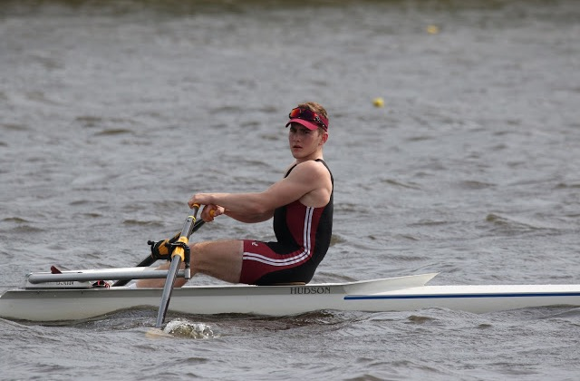

Boys lightweight double- Sam Daspin, Spencer Campbell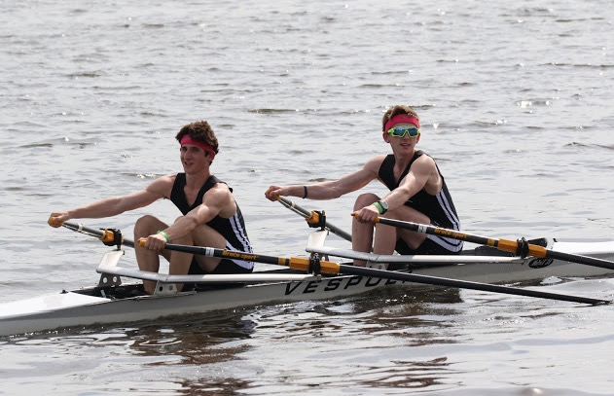

Girls JV 2x-Alexandra Walton Roth, Maddie Gibson  
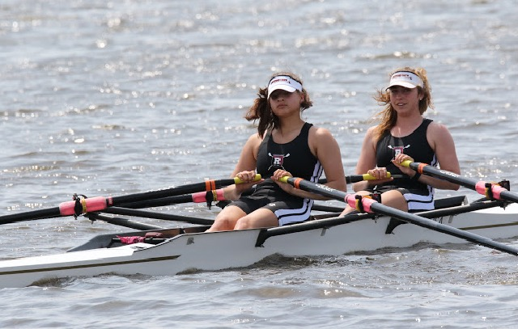

Girls Varsity 2x-Claire Callaghan, Jordan Witmaack

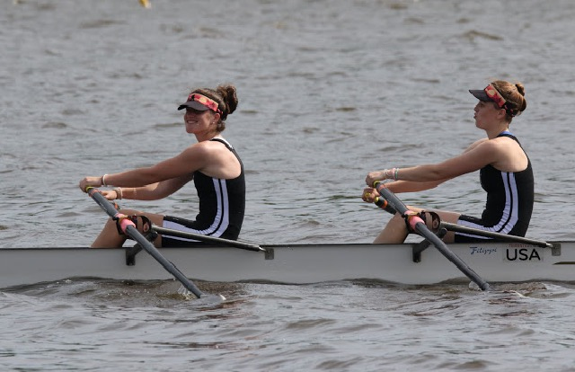

Girls Freshman 4x-Nicole Kye, Holly Sisco, Anna Soderlund, Lexi Liu.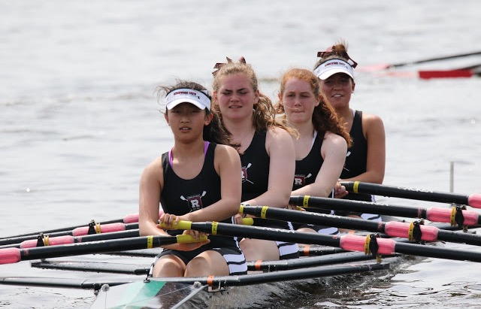

Photo Credit: Ed Hida