News for Immediate Release

Contact: Stacey Kliesch

201.655.4032

staceykliesch@gmail.com

Ridgewood Crew Competes in the

Head of the Schuylkill Regatta

Ridgewood, New Jersey, October 27 & 28, 2018 – This weekend, Ridgewood Crew competed in what is known as America’s Favorite Regatta, The Head of the Schuylkill in Philadelphia, Pennsylvania. In it’s 48th year, this two-day event, drew thousands of spectators to Fairmount Park and the 2.5 mile course.
Head Coach Boris Roque-Alvarez, veteran coach Bob O’Connor and novice coaches Margaret Dudrear, and James Trunley oversaw the rowers’ 17 events against nearly 300 total teams and over 8,000 athletes.

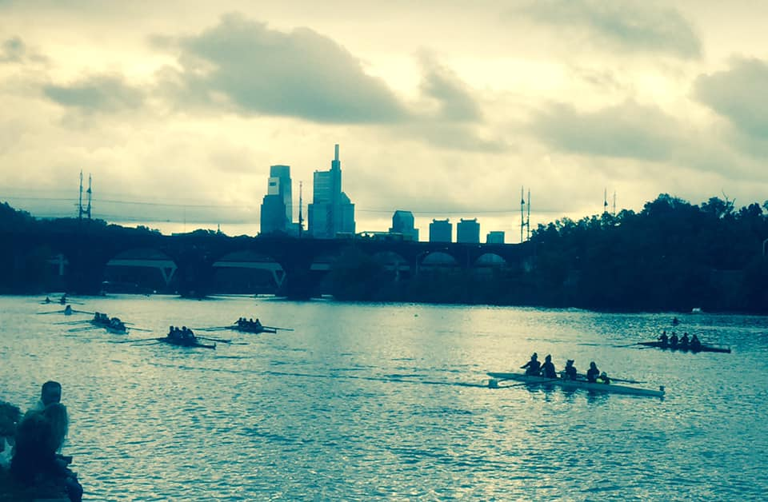
Photo by Jeanne Johnson

The Top Finishers were:

2nd Place Women’s High School Quad (JV) Victoria Hoy, Lauren Sudol, Anna Soderlund, Victoria Lyakerman
3rd Place Men’s High School Quad (Freshmen/ Novice) Andrew Krusac, Tommy Gammer, Francis Hamilton, Donn Patrick Jospeh
3rd Place Women’s High School Quad (Freshmen. Novice) Llian Riedel, Caroline Villemoes, Larah Gutierrez-Camano, Isabel Lee

About Ridgewood Crew
Ridgewood Crew not only introduces participants to basic and advanced rowing techniques, but also instills and promotes character values including discipline, focus, teamwork and sportsmanship. Ridgewood Crew rowers are challenged individually and as a team. The philosophy of Ridgewood Crew is to elevate each athlete to the status of MVP. By doing so, we believe that a team of young leaders emerges. These leaders not only make fast boats, but also significant contributions toward their individual pursuits.
Ridgewood Crew introduces Ridgewood, NJ high school-aged youth to the traditions, athleticism, sportsmanship, techniques and camaraderie of the sport of rowing. Founded in 2004, the team rows on the Passaic River in northern NJ and competes in the sport’s premier regattas held throughout the Northeast.
In the program's short history, our youth, board and parent volunteers have moved Ridgewood Crew forward by leaps and bounds. That success is represented by the widespread individual and team achievements of each of the student-athletes on the roster. To facilitate that success, Ridgewood Crew continues to make investments in coaching and new equipment. The coaching staff is one of the most experienced in program history.
Ridgewood Crew athletes compete in the Philly Flicks on the Schuylkill River as well as at the highly competitive SRAA Nationals, Stotesbury Cup Regatta, Philadelphia City Championships, Passaic River Northern NJ Championships and Garden State Championships. Additionally, the team's overall performance continues to attract interest from top rowing colleges and universities including: Bucknell, Boston College, Boston University, Columbia University, Drexel, Duke, Fairfield, Fordham, George Mason, Georgetown, Harvard, Holy Cross, Lehigh, Marist, Notre Dame, Syracuse, Trinity College, University of Delaware, Williams, and others.
Ridgewood Crew offers several ways for you to experience our mission: join the team, volunteer or donate. Student athlete programs being with Learn-To-Row for middle school schoolers.
For more information, to support or join the team, contact Ridgewood Crew at http://www.ridgewoodcrew.com ###

