News for Immediate Release

Contact: Stacey Kliesch

201.655.4032

staceykliesch@gmail.com

Ridgewood Crew Sends Elite Rowers to USRowing Mid-Atlantic Youth Championship Regatta and Comes Home with Two Gold Medals!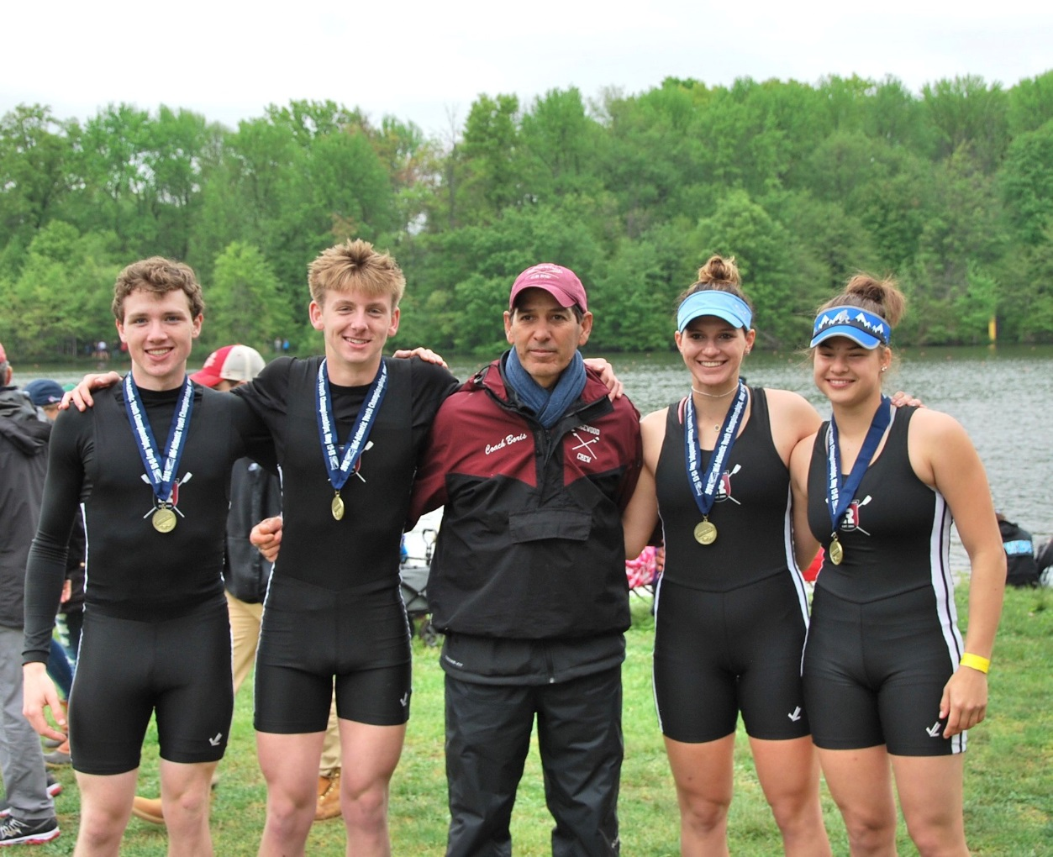

Coach Boris Roque Alvarez with Gold Medalists Joseph O’Keefe, Spencer Campbell, Amanda Perez and Alexandra Walton Roth. Photo by Karen Vonder Meulen

West Windsor, New Jersey, May 12-13, 2018 – Most of the Ridgewood Crew Team stayed home this past weekend to prepare for the upcoming Stotesbury Cup while three Varsity Crews traveled to Mercer Lake to compete in the USRowing Mid-Atlantic Youth Championship Regatta. The crews competing at the Youth Nationals used this 2000-meter course as preparation regatta, as they had to race against some of the strongest rowing clubs and scholastic rowing programs of the Mid-Atlantic Region that participated in this event.

Top competitors Ed Hida and Alex Saladucha faced some very tough competition in the Men’s Youth 2x on Saturday. They finished 4th in their preliminary heat.

Amanda Perez and Alexandra Walton Roth competed in the Women’s Youth 2x, placing first in the preliminary heats of that event against 11 other boats. The following day, the ladies dominated their final race, finishing first once again, trimming 13 seconds from their previous days’ time.

The Men’s Youth Ltwt 2x enjoyed similar success. Rowers Joseph O’Keefe and Spencer Campbell finished first out of 12 boats in the qualifying heats and then went on to shave 11 seconds from their time in the finals and captured the gold!

About Ridgewood Crew
Ridgewood Crew not only introduces participants to basic and advanced rowing techniques, but also instills and promotes character values including discipline, focus, teamwork and sportsmanship. Ridgewood Crew rowers are challenged individually and as a team. The philosophy of Ridgewood Crew is to elevate each athlete to the status of MVP. By doing so, we believe that a team of young leaders emerges. These leaders not only make fast boats, but also significant contributions toward their individual pursuits.
Ridgewood Crew introduces Ridgewood, NJ high school-aged youth to the traditions, athleticism, sportsmanship, techniques and camaraderie of the sport of rowing. Founded in 2004, the team rows on the Passaic River in northern NJ and competes in the sport’s premier regattas held throughout the Northeast.
In the program's short history, our youth, board and parent volunteers have moved Ridgewood Crew forward by leaps and bounds. That success is represented by the widespread individual and team achievements of each of the student-athletes on the roster. To facilitate that success, Ridgewood Crew continues to make investments in coaching and new equipment. The coaching staff is one of the most experienced in program history.
Ridgewood Crew athletes compete in the Philly Flicks on the Schuylkill River as well as at the highly competitive SRAA Nationals, Stotesbury Cup Regatta, Philadelphia City Championships, Passaic River Northern NJ Championships and Garden State Championships. Additionally, the team's overall performance continues to attract interest from top rowing colleges and universities including: Bucknell, Boston College, Boston University, Columbia University, Drexel, Duke, Fairfield, Fordham, George Mason, Georgetown, Harvard, Holy Cross, Lehigh, Marist, Notre Dame, Syracuse, Trinity College, University of Delaware, Williams, and others. The program also celebrated its first female athlete to receive a full, four-year rowing scholarship.
Ridgewood Crew offers several ways for you to experience our mission: join the team, volunteer or donate. Student athlete programs being with Learn-To-Row for middle school schoolers.
For more information, to support of join the team, contact Ridgewood at http://www.ridgewoodcrew.com
###

