**From:** Jeanne Hope <[jeannehope@yahoo.com](mailto:jeannehope@yahoo.com)>  
**Date:** May 8, 2017 at 12:16:40 PM EDT  
**To:** Darren Cooper <[CooperD@northjersey.com](mailto:CooperD@northjersey.com)>, Daniel Hubbard <[daniel.hubbard@patch.com](mailto:daniel.hubbard@patch.com)>, George Thompson <[georgethompson1491@gmail.com](mailto:georgethompson1491@gmail.com)>, Cecilia Levine <[clevine@dailyvoice.com](mailto:clevine@dailyvoice.com)>, Adam Brunner <[abrunner@ridgewood.k12.nj.us](mailto:abrunner@ridgewood.k12.nj.us)>  
**Cc:** Eugene Callaghan <[genec189@gmail.com](mailto:genec189@gmail.com)>  
**Subject:** **Ridgewood Crew/photos**

Philadelphia Scholastic Rowing Association (PSRA)City Championships

Ridgewood Crew had another great weekend of racing as the boys and girls traveled down to Philadelpihia for the City Championship, a regional championship that includes high school teams from the mid-Atlantic region. Against a competitive field, Ridgewood was able to come away with many excellent results in this two day event.

The first day served as a qualifying round for crews to advance to semi-finals and finals on Sunday. 11 of the 15 entries advanced to Sunday’s racing.

Sunday featured racing that matched the intensity of the rapidly changing weather. Ridgewood rowers battled both the other crews and gusting winds down the race course.

Sunday morning, the boys junior varsity doubles rowed by Drew Johnson and Alex Melarti; and Sebastian Rivero and Walter Friedrich qualified for their finals by finishing in the top three in their respective semi-final heats.

Sunday afternoon the finals started and Ridgewood did not disappoint regardless of the conditions. Ridgewood carried 11 crews into finals in 10 events. Of the crews in finals, 8 came away with medals; 4 crews came away with bronze medals, 3 crews received silver medals, and the varsity girls double of Claire Callaghan and Jordan Wittmaack came away with gold.

Bronze

* Girls Freshman 4x (Nicole Kye, Holly Sisco, Khushi Patel, and Anna Soderlund)
* Boys Junior Varsity 2x (Drew Johnson and Alex Melarti)
* Girls Varsity Lightweight 2x (Maddy Phillips and Emily Gilman)
* Boys Varsity Lightweight 2x (Sam Daspin and Spencer Campbell)

Silver

* Girls Junior Varsity 2x (Alexandra Walton Roth and Maddie Gibson)
* Boys Junior Varsity 4x (Edward Hida, Alex Saladucha, Joe O’Keefe, and Henry Koontz)
* Girls Varsity 4x (Isabella DeGregorio, Chloe Young, Amanda Perez, and Melissa Dexter)

Gold

* Girls Varsity 2x (Claire Callaghan and Jordan Wittmaack)

In the girls varsity double, the crew had to fight back from behind to secure the victory. According to Senior gold medalist Claire Callaghan, “the other crews went out quickly in the first 500 meters” of the 1500 meter competition, but the double “stuck to and executed our race plan and were able to move through the competition.”

“I have great memories from racing at City’s and have won 3 golds and a silver in my four years of competing here,” says Callaghan.

Select crews will travel to Lake Mercer next weekend for the USRowing Mid-Atlantic Youth Championship. There, crews will attempt to qualify for the USRowing Youth National Championship Regatta held in Sarasota, Florida this June.

Pictured:

Silver Medalists

Girls JV 2x

Alexandra Walton Roth, Maddie Gibson  
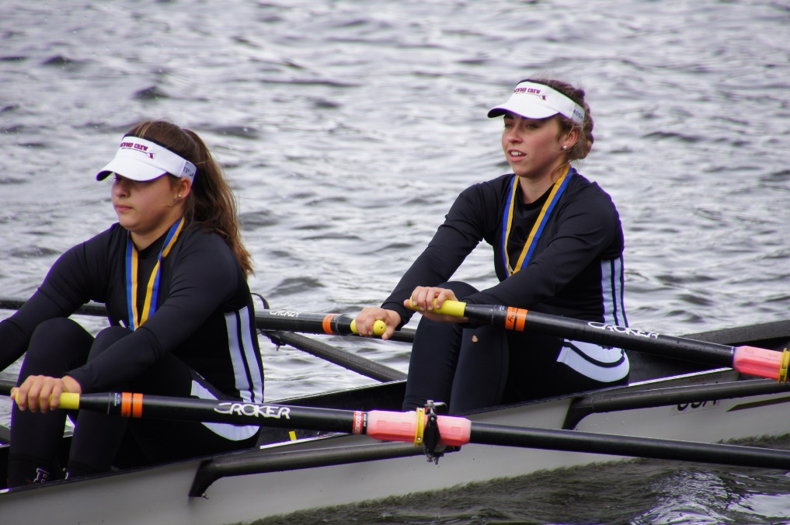

Photo: Claus Melarti

Silver Medalists

Boys JV 4

Edward Hida, Alex Saladucha, Joe O’Keefe, Henry Koontz

Photo: Claus Melarti

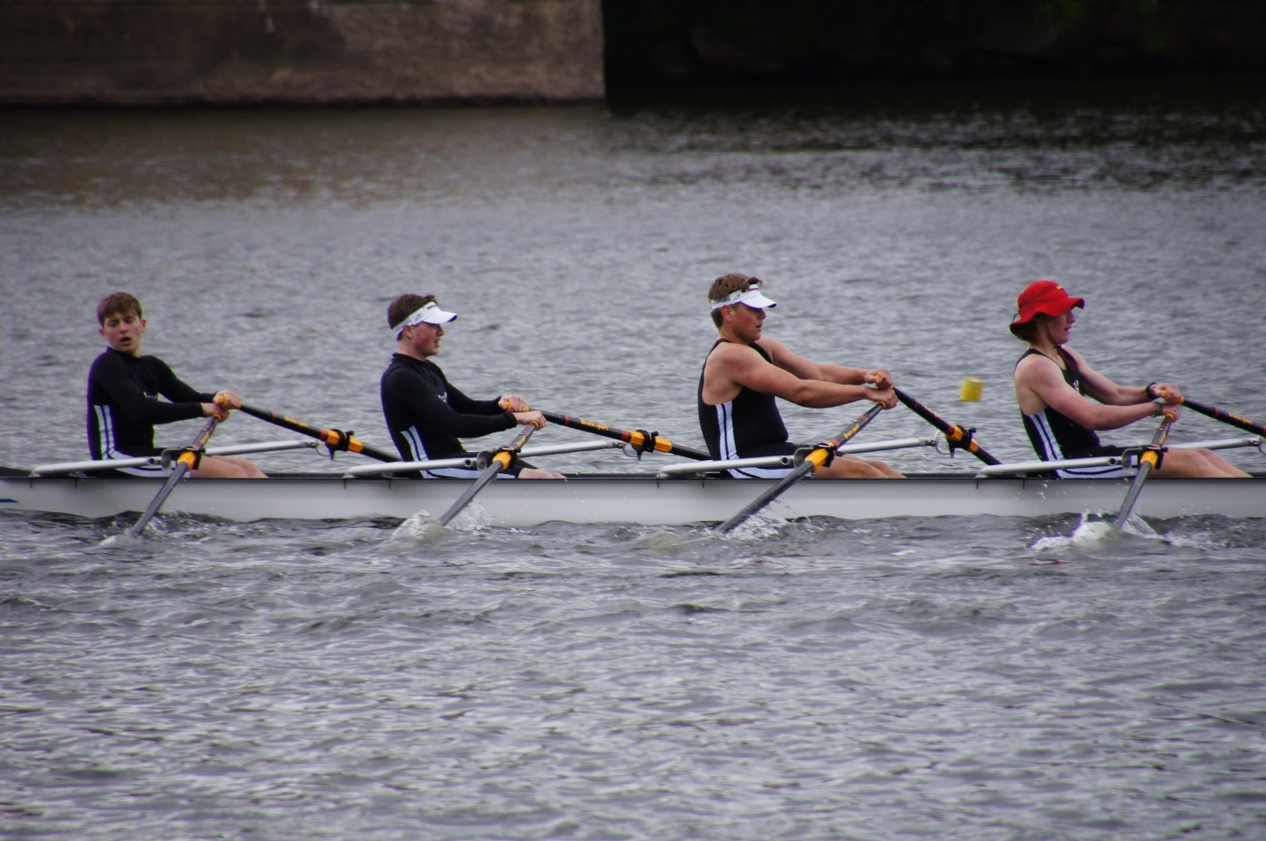

Gold Medalists

Girls Varsity 2x

Claire Callaghan, Jordan Wittmaack

Coaches: Bob O'Conner

Boris Roque Alvarez  
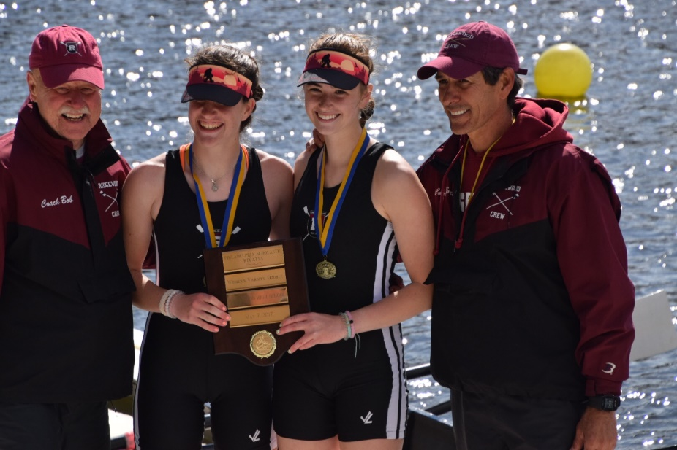

Photo: Terry Wittmaack   
  
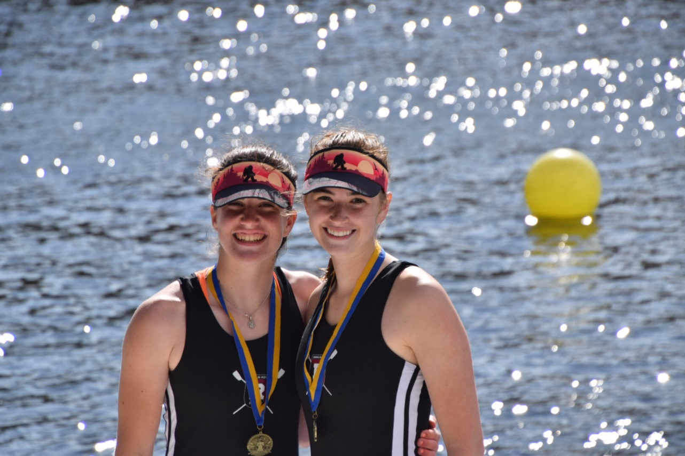

Photo:Terry Wittmaack

Bronze Medalists

Boys JV 2xDrew Johnson, Alex Melarti,Coach Boris Roque Alvarez  
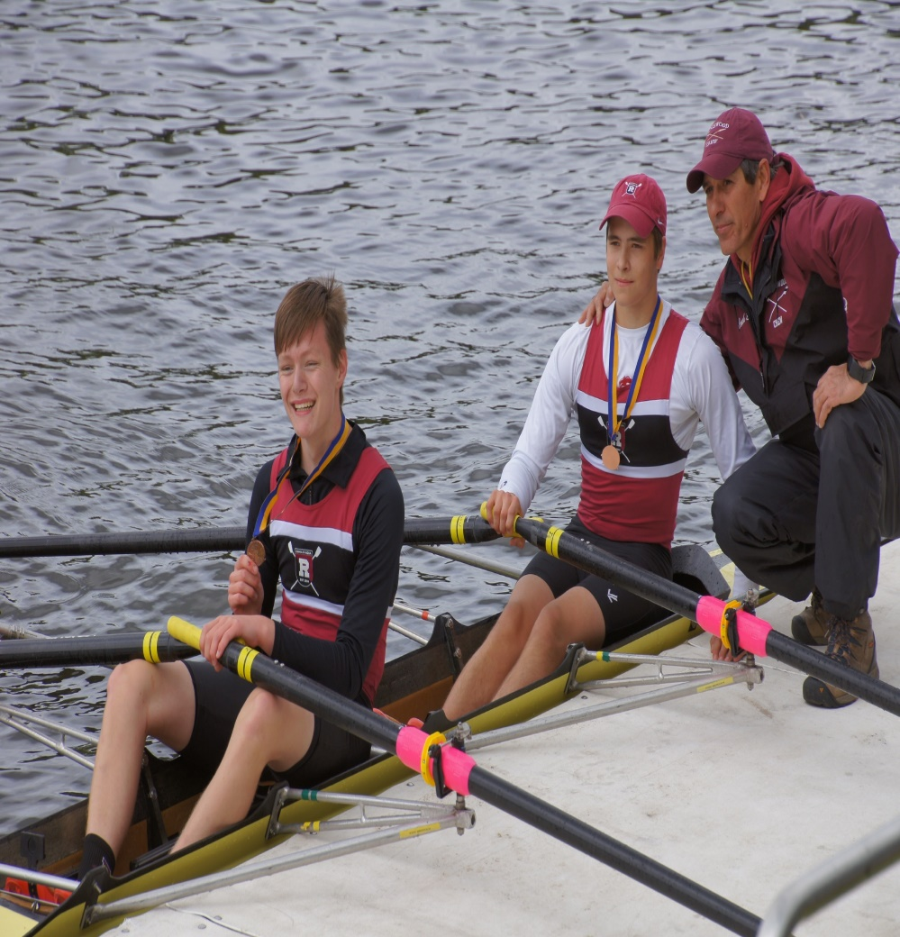

Photo:Claus Melarti 