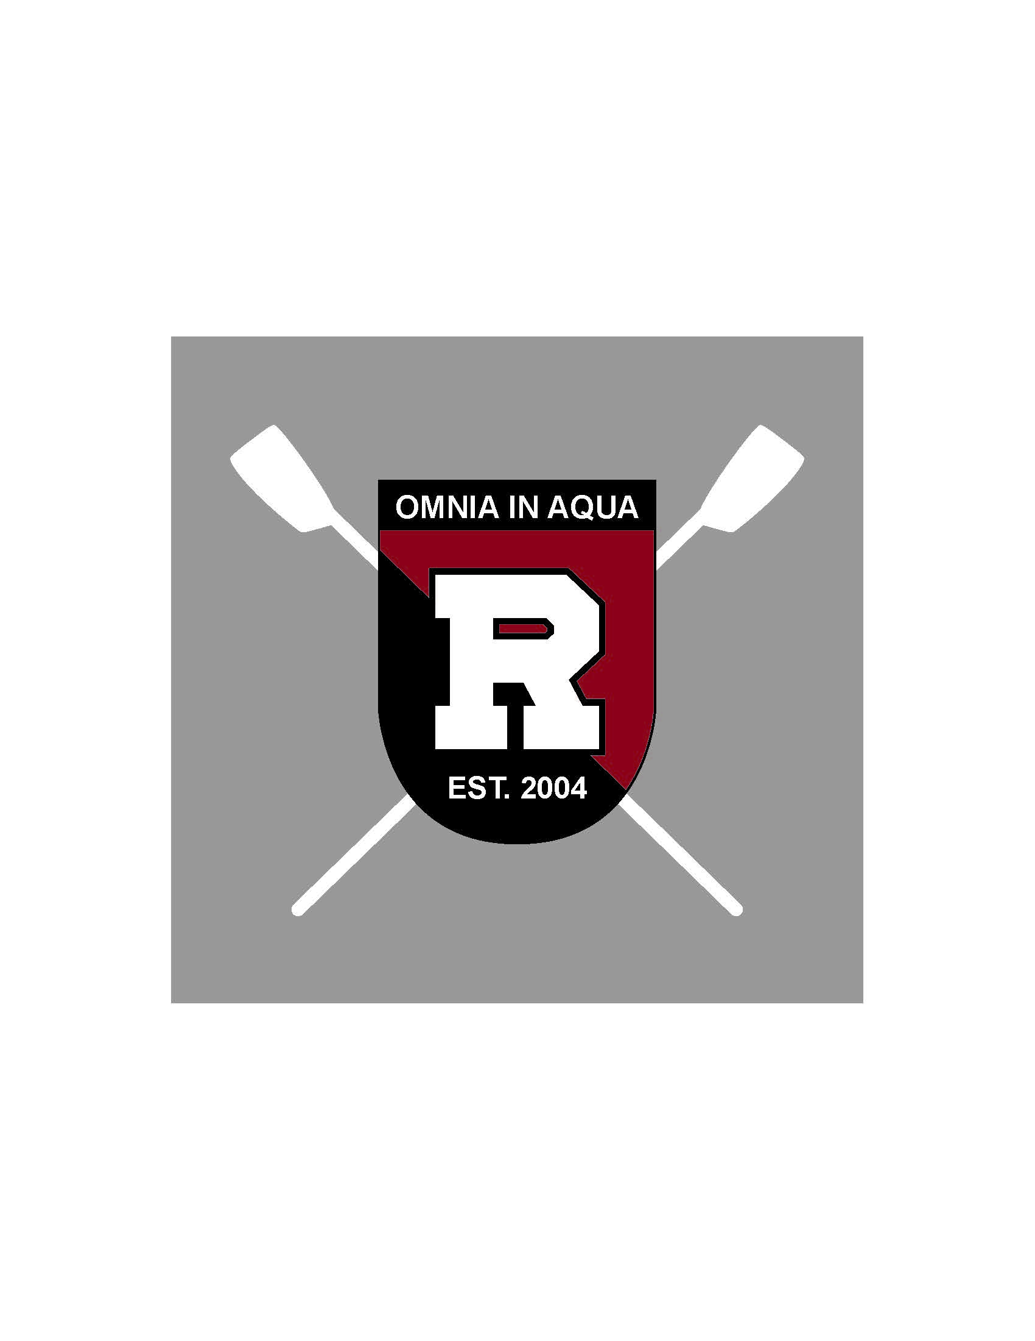
PARENT/GUARDIAN LIABILITY WAIVER & EMERGENCY CONTACT FORM

Child’s Name: ________________________________________________________________

I, the parent/guardian of the above-named child, hereby give my full consent and approval to his/her registration and participation in Ridgewood Crew for the 2016-2017 season, including participation in pre-tryout training or conditioning. I understand that there are certain risks of injury inherent in the practice and races of crew, as well as transporting my child to or from any of the regattas or crew-related events, and I am willing to assume all risks and hazards incidental to the conduct of such activities.

I hereby confirm that my child is fully capable of participating in the sport of crew and that my child is in sound medical condition and has no physical or mental disabilities or conditions that would restrict full participation, except as noted below. Please include all known allergies.

Physical Disabilities, Medical Conditions and/or Allergies:
Physician Name & Number: _____________________________________________________

In the event of my absences, if my son/daughter is suffering from an injury or condition requiring diagnosis and immediate medical or surgical treatment, I do hereby voluntarily authorize Ridgewood Crew coaches, Board members, and/or parent volunteers at the scene to consent to such diagnostic procedures, medical/hospital care, medication administration, and to such medical, surgical, or x-ray treatment as may be deemed necessary by and under the direct authorization of a licensed physician/practitioner.

Emergency Contact Info:

Parent #1 Name: _____________________________________________________________

Cell: ____________________; Work: ___________________; Home: ___________________

Parent #2 Name: _____________________________________________________________

Cell: ____________________; Work: ___________________; Home: ___________________

Page 1 of 2

Emergency Contact Info (Continued):

Emergency Contact Name: _____________________________________________________

Cell: ____________________; Work: ___________________; Home: ___________________

Emergency Contact Name: _____________________________________________________

Cell: ____________________; Work: ___________________; Home: ___________________

In addition, I hereby release, absolve, and discharge Ridgewood Crew and its officers, directors, coaches, sponsors, supervisors, representatives, and any person transporting my child to and from any of the activities from any claim or liability in case of an accident, injury and/or medical and dental expenses incurred to my child.

Signature of Parent/Guardian: ______________________________ Date: ____________
Name of Parent/Guardian: __________________________________

Revised November 2016

Page 2 of 2

