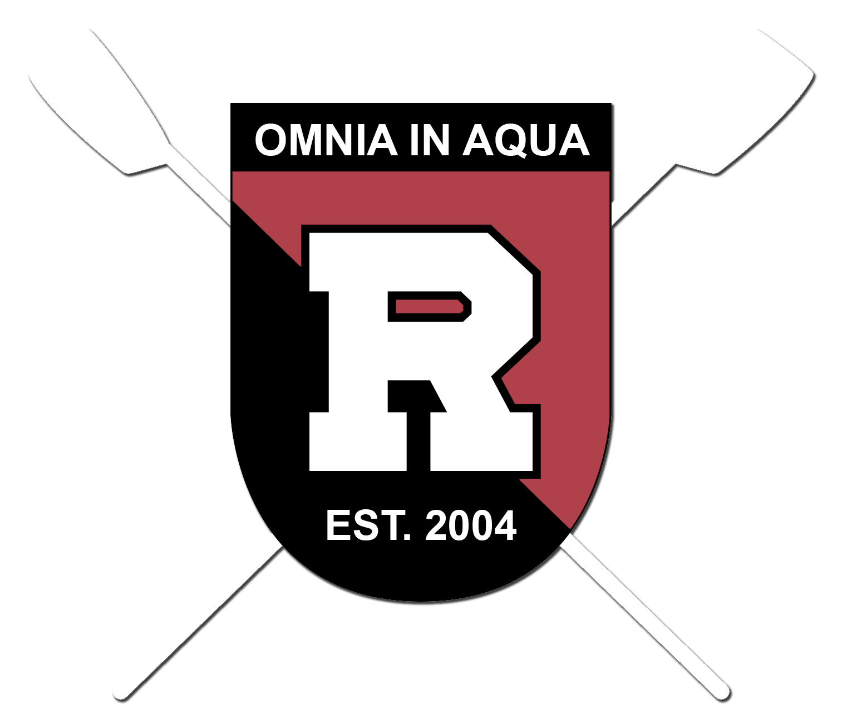
16th ANNUAL
RIDGEWOOD CREW
ROW-A-THON

Saturday March 24, 2018
Van Neste Square Park in Ridgewood

Please Check One or More…

___ Bronze Level: $200 – Sponsor’s company Ad on Lawn Sign at Event.

___ Silver Level: $350 – Sponsor’s Logo on Ridgewood Crew’s website.

___ Gold Level: $500 – Sponsor’s company Ad on Lawn Sign at the Event and Sponsor’s Logo on Ridgewood Crew’s website.

___ Platinum Level: $1,000 - Sponsor’s company Logo on Banner at the Event and on Ridgewood Crew’s website. Banner will be displayed at all Regattas for the year.

___ Diamond Level: $5,000+ - Sponsor’s company Logo on Banner at the Event, Ridgewood Crew’s Cargo Trailer and website. Banner will be displayed at all Regattas for the year.

___ Name-a-Boat Donation: $10,000+ - Name a Boat for the life of the boat and Sponsor’s company Logo on Ridgewood Crew’s website for the life of the boat.

*Make all checks payable to: Ridgewood Crew

** Please Submit Logos/Artwork in pdf format to: ridgewoodcrewfundraising@gmail.com

Deadline for Logo Submission is March 15th, 2018

