It’s time for the Annual

Ridgewood Crew
Row-A-Thon!

Saturday March 24, 2018
Van Neste Square Park in Ridgewood
First Name: Last Name:
Dear Potential Sponsor,
I am participating in the Ridgewood Crew Row-A-Thon. All proceeds will help fund our season. All pledges will be for a flat rate as all the athletes will complete their assigned session. Please make checks out to Ridgewood Crew.
Thank you!
Name of Sponsor |  | Cash | Check # | Amount Collected from Sponsor | Sponsor Phone/Email
1
2
3
4
5
6
7
8
9
10
11
12
13
14
15
16
17
18

Participants:
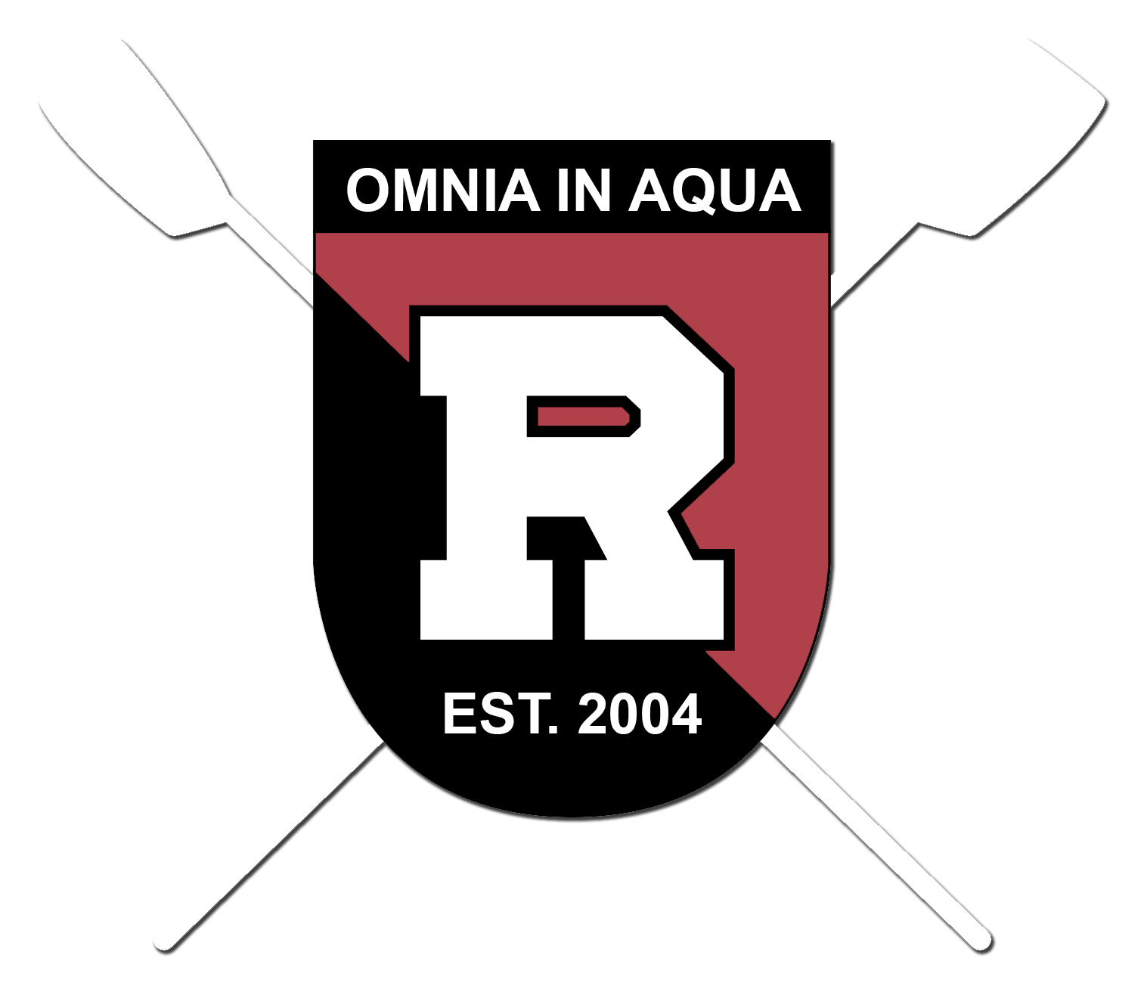
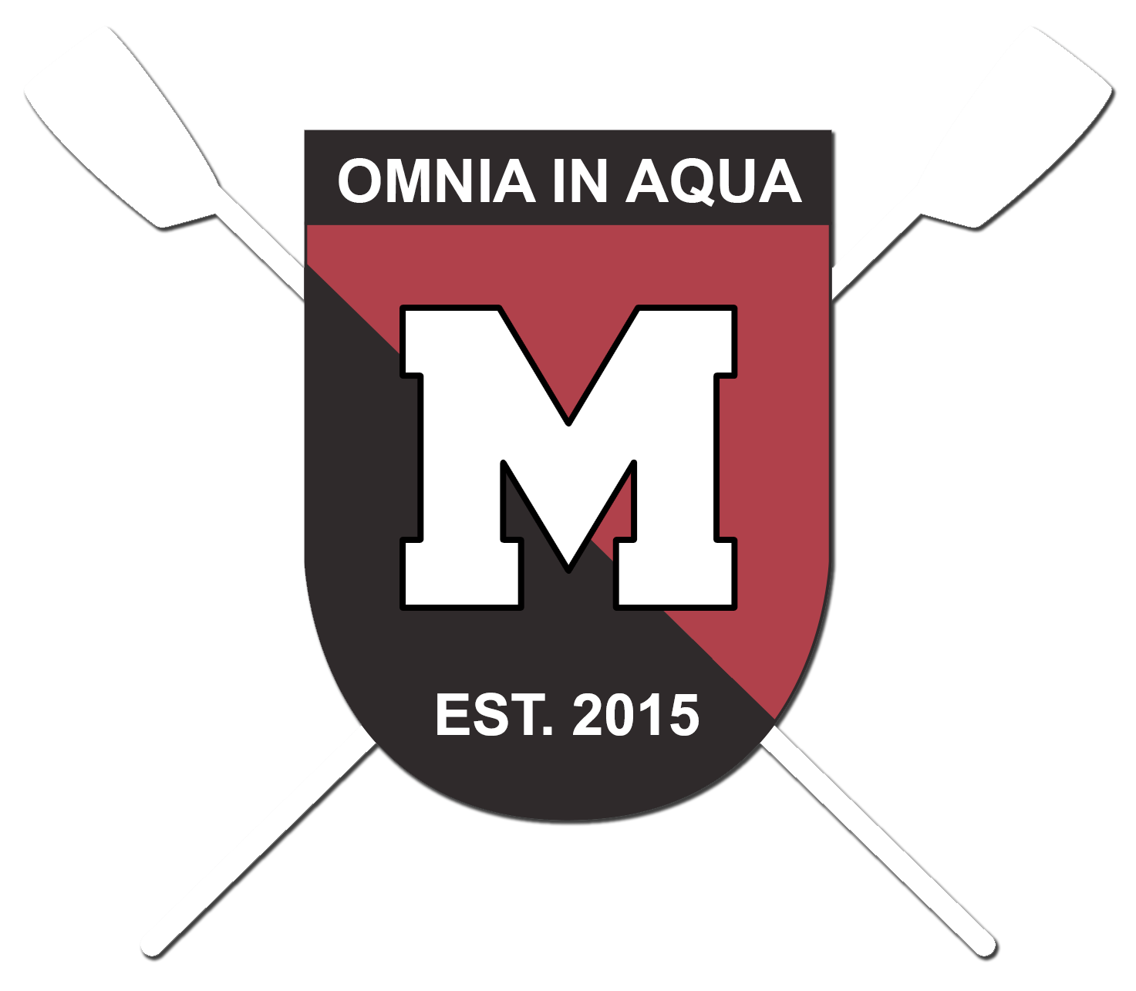
Each Rower is Required to raise a minimum of $300. (That’s $10 from 30 people or $30 from 10 people or $100 from 3 people or 1 donation of $300). But for those more aggressive with fundraising, there are some incentives... Top dollar amount raised over $1,500 receives a $600 Gift Card, 2nd Place will receive a $400 Gift Card and 3rd Place will receive a $200 Gift Card.

