News for Immediate Release

Contact: Stacey Kliesch

201.655.4032

staceykliesch@gmail.com

Ridgewood Crew Returns from The Scholastic Rowing Association of America® National Championships with Three New Medals

Pennsauken, New Jersey, May 25-26, 2018 –
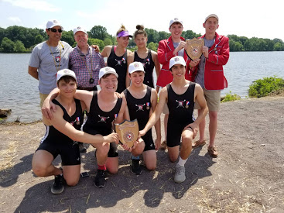
(Top Row, L-R) Coaches Boris Roque-Alvarez and Bob O'Connor, athletes Amanda Perez, Alexandra Walton-Roth, Joseph O'Keefe, Spencer Campbell, (Bottom Row, L-R) Alex Melarti, Drew Johnson, Tom Montgomery and Sebastian Rivero display their awards. Photo by Elisa Rivero.

Ridgewood Crew headed down to Cooper River Park for the last time this season to race in The Scholastic Rowing Association of America® National Championships on May 25th and 26, 2018. Of the eleven Ridgewood Crew boats registered to compete in regatta, four progressed to the finals on day two.

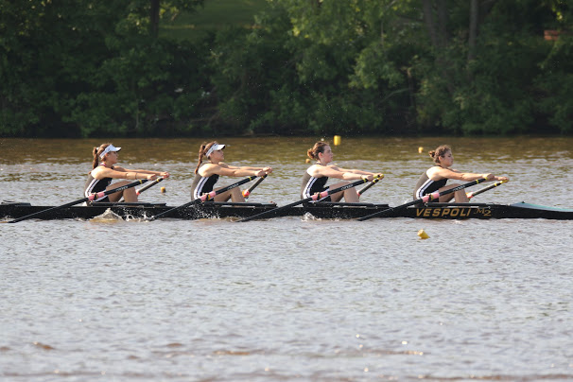

The rookie crew of the Girls Freshmen 4x, rowed by (L-R) Victoria Hoy, Payton Kliesch, Lauren Sudol and Victoria Lyakerman, were the last boat to qualify for their event on day one. In the finals, they gave it their all, pulling ahead of two boats to finish just shy of medaling. Their final time was 5:55.992. Photo by Ed Hida.
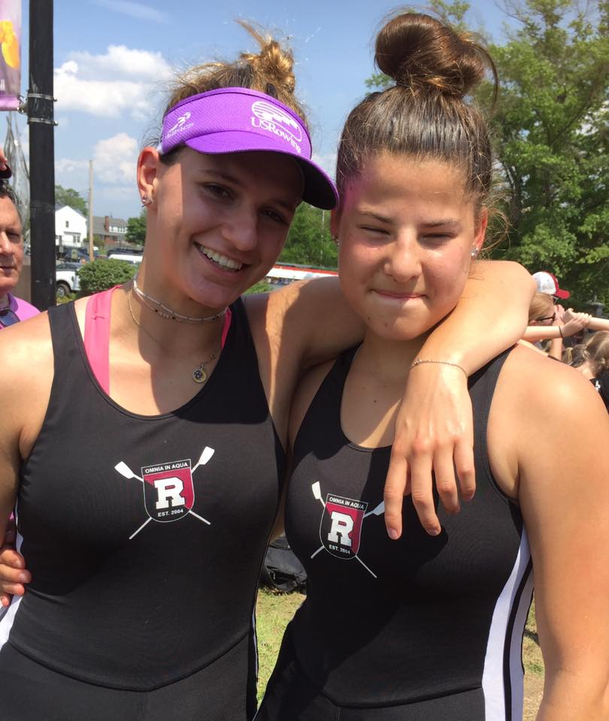

Powerhouse duo Amanda Perez and Alexandra Walton-Roth gave the crowd the thrill of the day with an unbelievable neck-and-neck finish against Freemont. The athletes brought home the Silver Medal in the Girls Varsity 2x, missing gold by a mere .004 of a second! Their final time was 5:37.409. Photo by Jeanne Johnson.
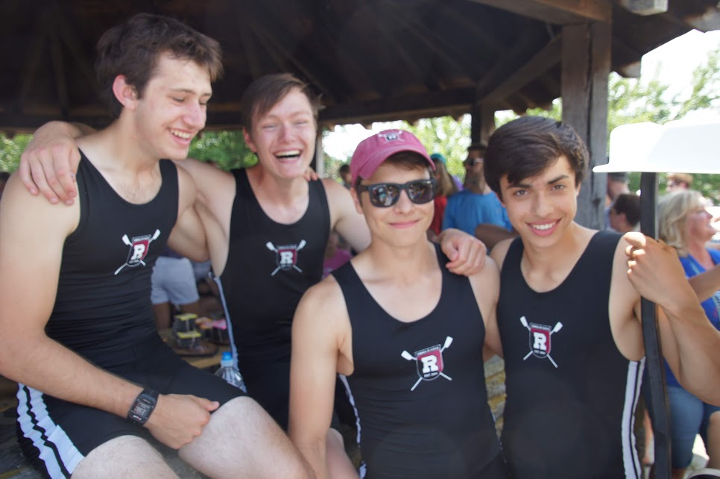
The Boys Junior Quad, rowed by (L-R) Tom Montgomery, Drew Johnson, Alex Melarti and Sebastian Rivero, crushed their final race to win the Gold Medal with a time of 4:46.440. Photo by Elise Rivero.

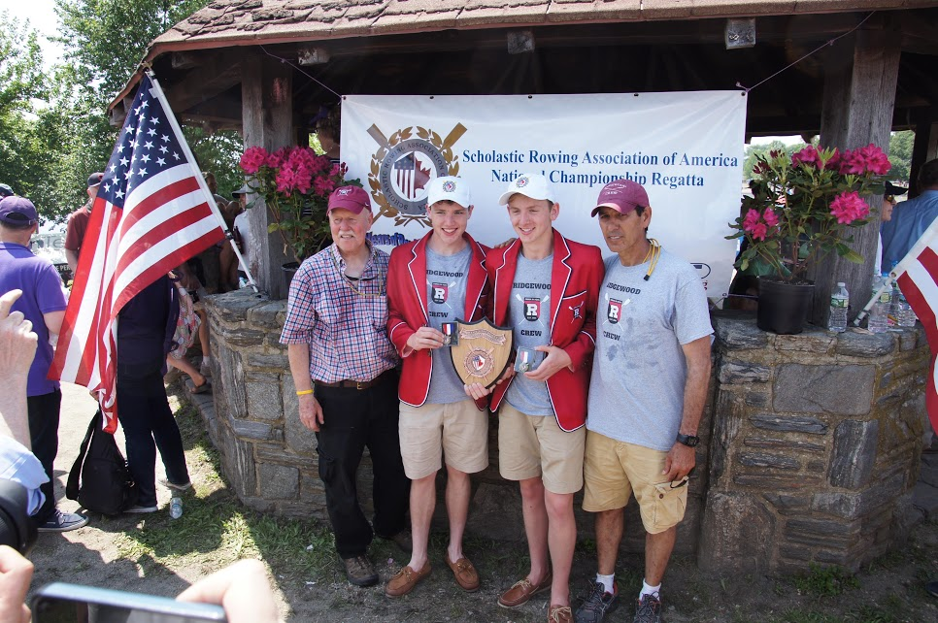

Coaches Bob O’Conner and Boris Roque-Alvarez joined red-coated Joe O’Keefe and Spencer Campbell of the Boys Lightweight Double to collect Gold Medals once again for their outstanding performance. Their winning time was 5:14.108. Photo by Elisa Rivero.

History of the event: SRAA conducted their first annual regatta in May of 1935 under their original name, the Schoolboy Rowing Association of America. The name was changed to the Scholastic Rowing Association of America® in 1976 to reflect the addition of women athletes.
The primary function of the SRAA® is to run the Scholastic Championship Regatta each May, determining the North American Champions. Ridgewood Crew is proud to recognized by this most prestigious organization.

Campbell, O’Keefe, Perez and Walton-Roth will be joined in Gold River, CA by Maddie Gibson, Alex Saladucha and Ed Hida as their four boats take on our nation’s best at the 2018 USRowing Youth National Championships, June 8-10, 2018.

About Ridgewood Crew
Ridgewood Crew not only introduces participants to basic and advanced rowing techniques, but also instills and promotes character values including discipline, focus, teamwork and sportsmanship. Ridgewood Crew rowers are challenged individually and as a team. The philosophy of Ridgewood Crew is to elevate each athlete to the status of MVP. By doing so, we believe that a team of young leaders emerges. These leaders not only make fast boats, but also significant contributions toward their individual pursuits.
Ridgewood Crew introduces Ridgewood, NJ high school-aged youth to the traditions, athleticism, sportsmanship, techniques and camaraderie of the sport of rowing. Founded in 2004, the team rows on the Passaic River in northern NJ and competes in the sport’s premier regattas held throughout the Northeast.
In the program's short history, our youth, board and parent volunteers have moved Ridgewood Crew forward by leaps and bounds. That success is represented by the widespread individual and team achievements of each of the student-athletes on the roster. To facilitate that success, Ridgewood Crew continues to make investments in coaching and new equipment. The coaching staff is one of the most experienced in program history.
Ridgewood Crew athletes compete in the Philly Flicks on the Schuylkill River as well as at the highly competitive SRAA Nationals, Stotesbury Cup Regatta, Philadelphia City Championships, Passaic River Northern NJ Championships and Garden State Championships. Additionally, the team's overall performance continues to attract interest from top rowing colleges and universities including: Bucknell, Boston College, Boston University, Columbia University, Drexel, Duke, Fairfield, Fordham, George Mason, Georgetown, Harvard, Holy Cross, Lehigh, Marist, Notre Dame, Syracuse, Trinity College, University of Delaware, Williams, and others. The program also celebrated its first female athlete to receive a full, four-year rowing scholarship.
Ridgewood Crew offers several ways for you to experience our mission: join the team, volunteer or donate. Student athlete programs being with Learn-To-Row for middle school schoolers.
For more information, to support of join the team, contact Ridgewood at http://www.ridgewoodcrew.com
###

