News for Immediate Release

Contact: Stacey Kliesch

201.655.4032

staceykliesch@gmail.com

Ridgewood Crew Wins 8 Medals at the

City Championship Regatta in Philadelphia

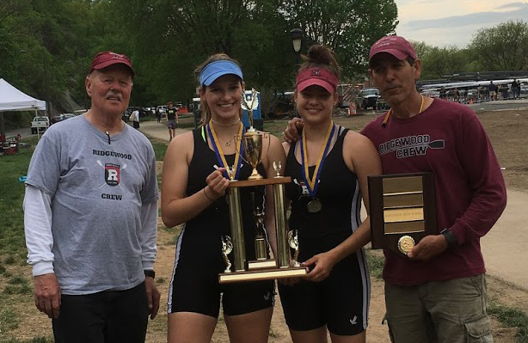
Figure 1 Coaches Bob O'Conner and Boris Roque Alvarez with Gold Medalists Amanda Perez and Alexandra Walton Roth. Photo by Judy Wong

Philadelphia, Pennsylvania, May 5-6, 2018 – This weekend, the Ridgewood Crew team competed in the two-day City Championship Regatta on the Skuylkill River, hosted by the Philadelphia Scholastic Rowing Association. Seventy-eight Mid-Atlantic regional clubs participated in this invitational event, with qualifying races on Saturday and Sunday morning and the finals on Sunday afternoon.
Ridgewood Crew entered 16 boats into the same number of events. Fourteen crews competed in a qualifying round on Saturday with 12 advancing to finals. A spectacular 6 of those 12 finished first in their event.
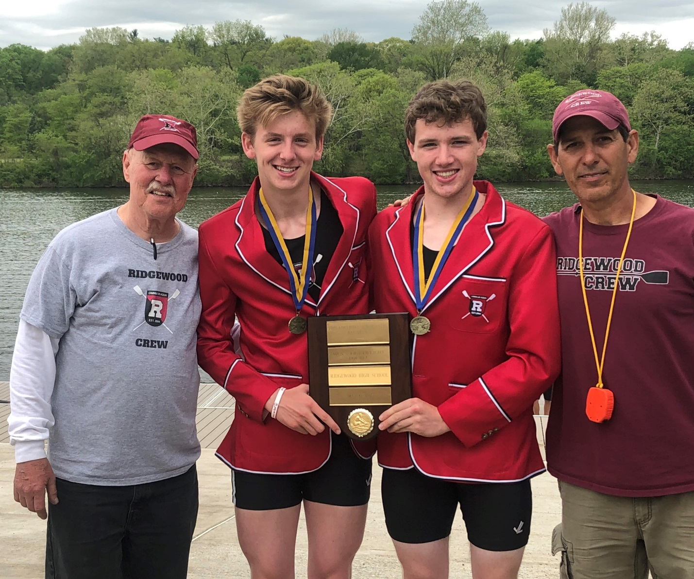
Figure 2 Coaches Bob O’Conner and Boris Roque Alvarez with Gold Medalists Spencer Campbell and Joseph O'Keefe. Photo by Boris Alvarez
Sunday saw greater challenges for the team, but the 14 crews racing still yielded 3 gold medals, 2 silver medals and 3 bronze medals, matching last year’s total number of medals but with improved standing.
Coaches Boris Roque Alvarez and Bob O’Conner were very pleased with the results.
This year’s Bronze Medal Winners included the Boys Varsity 2x rowed by Edward Hida and Alex Saladucha; Maddy Gibson rowing the Girls Varsity 1x; and the Girls Novice 4x crew of Kim Rahnefeld, Jeanne-Marie Thomas, Diya Vij and Sara Wong.
Silver medals were awarded to Gabriel Martinez in the Boys Junior Varsity 1x and the Girls Junior Varsity 4x crew, Anna Soderland, Holly Sisco, Nicole Kye and Lexi Liu.
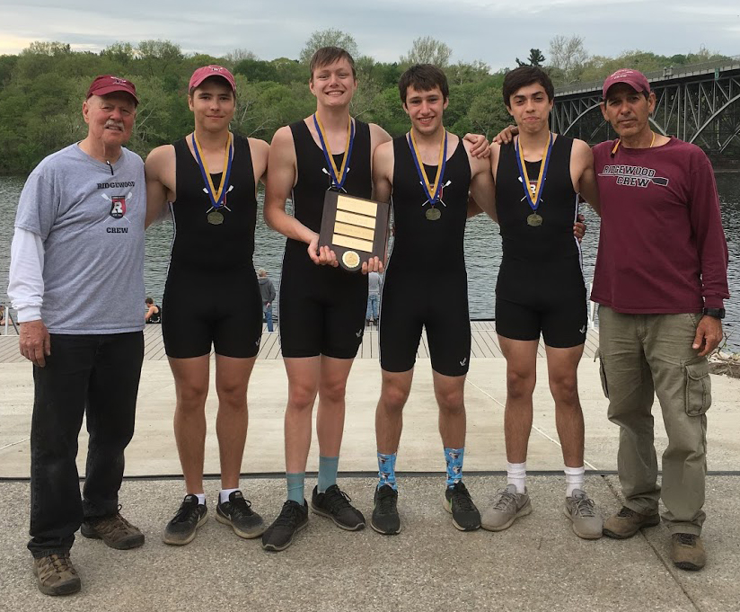
Figure 3 Coaches Bob O'Conner and Boris Roque Alvarez with Gold Medalists Alex Melarti, Drew Johnson, Thomas Montgomery and Sebastian Rivero Photo by Judy Wong
Taking home the gold were Girls Varsity 2x rowed by Amanda Perez and Alexandra Walton Roth; Boys Lightweight 2x rowed by Joseph O’Keefe and Spencer Campbell and Boys Junior Varsity 4x rowed by Alex Melarti, Drew Johnson, Thomas Montgomery and Sebastian Rivero.
Ridgewood Crew applied the performance at this event to qualify for the USRowing Youth National Championship Regatta being presented next month by Rancho Cordova Travel and Tourism on Lake Natoma in Gold River, CA. The following crews won their bids for that event: Girls Varsity 1x, Girls Varsity 2x and Boys Lightweight 2x. USRowing is still deciding on a fourth boat.
Mother’s Day weekend will see select crews on Mercer Lake in West Windsor, New Jersey for the USRowing Mid-Atlantic Youth Championships. The crews competing at the Youth Nationals will use this 2000-meter course as a training regatta, as our athletes will be racing beside some of the strongest scholastic program clubs of the Mid-Atlantic Region.

About Ridgewood Crew
Ridgewood Crew not only introduces participants to basic and advanced rowing techniques, but also instills and promotes character values including discipline, focus, teamwork and sportsmanship. Ridgewood Crew rowers are challenged individually and as a team. The philosophy of Ridgewood Crew is to elevate each athlete to the status of MVP. By doing so, we believe that a team of young leaders emerges. These leaders not only make fast boats, but also significant contributions toward their individual pursuits.
Ridgewood Crew introduces Ridgewood, NJ high school-aged youth to the traditions, athleticism, sportsmanship, techniques and camaraderie of the sport of rowing. Founded in 2004, the team rows on the Passaic River in northern NJ and competes in the sport’s premier regattas held throughout the Northeast.
In the program's short history, our youth, board and parent volunteers have moved Ridgewood Crew forward by leaps and bounds. That success is represented by the widespread individual and team achievements of each of the student-athletes on the roster. To facilitate that success, Ridgewood Crew continues to make investments in coaching and new equipment. The coaching staff is one of the most experienced in program history.
Ridgewood Crew athletes compete in the Philly Flicks on the Schuylkill River as well as at the highly competitive SRAA Nationals, Stotesbury Cup Regatta, Philadelphia City Championships, Passaic River Northern NJ Championships and Garden State Championships. Additionally, the team's overall performance continues to attract interest from top rowing colleges and universities including: Bucknell, Boston College, Boston University, Columbia University, Drexel, Duke, Fairfield, Fordham, George Mason, Georgetown, Harvard, Holy Cross, Lehigh, Marist, Notre Dame, Syracuse, Trinity College, University of Delaware, Williams, and others. The program also celebrated its first female athlete to receive a full, four-year rowing scholarship.
Ridgewood Crew offers several ways for you to experience our mission: join the team, volunteer or donate. Student athlete programs being with Learn-To-Row for middle school schoolers.
For more information, to support of join the team, contact Ridgewood at http://www.ridgewoodcrew.com
###

