News for Immediate Release

Contact: Stacey Kliesch

201.655.4032

staceykliesch@gmail.com

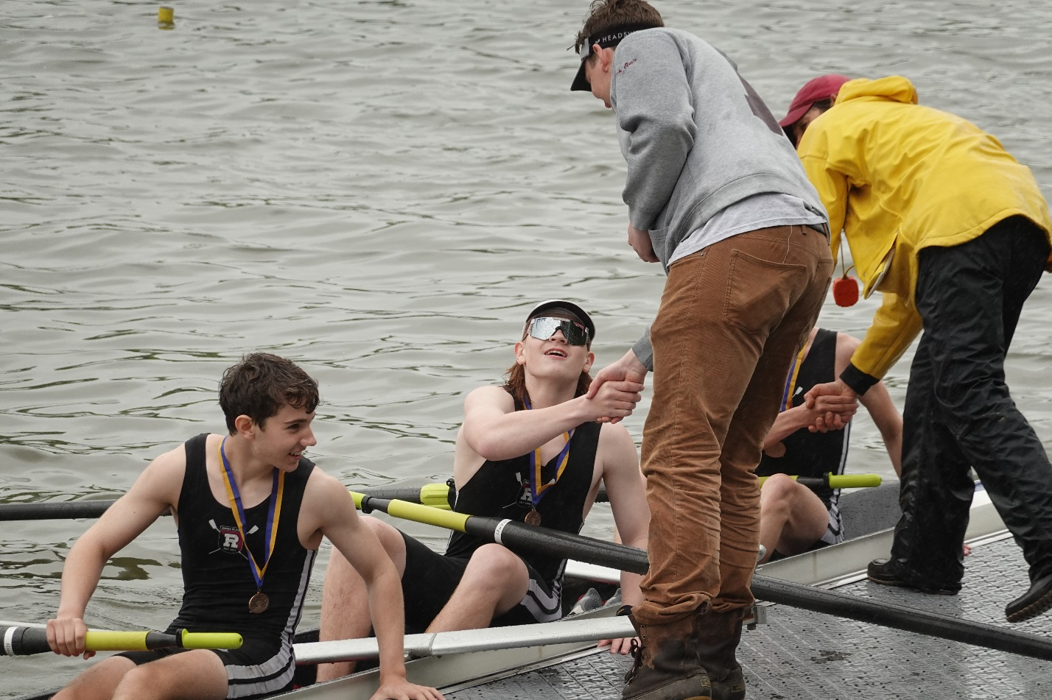
For the first time in Ridgewood Crew history, the Boys JV 8+ qualifies for the SRAA National Regatta! Photo by Edward Hida

Ridgewood Crew Achieves a New Milestone at the 2019 City Championship Regatta

Ridgewood, New Jersey, May 4-5, 2019 – Ridgewood Crew entered 14 events at this weekend’s Philadelphia Scholastic Rowing Association’s City Championship Regatta with only Lower Merion, PA; Montclair, NJ and Springside Chestnut Hill, PA entering more. Delightful weather on Saturday encouraged crowds along the Schuylkill River for the qualifying heats while the finals and semifinals on Sunday couldn’t have been soggier. The wet conditions did nothing to dampen the athletes’ moral, with 11 boats advanced to the finals and 5 boats earning medals.
City Championship Regatta Results from Sunday Finals:
Girls Freshman 4x 1st place 5:26.770
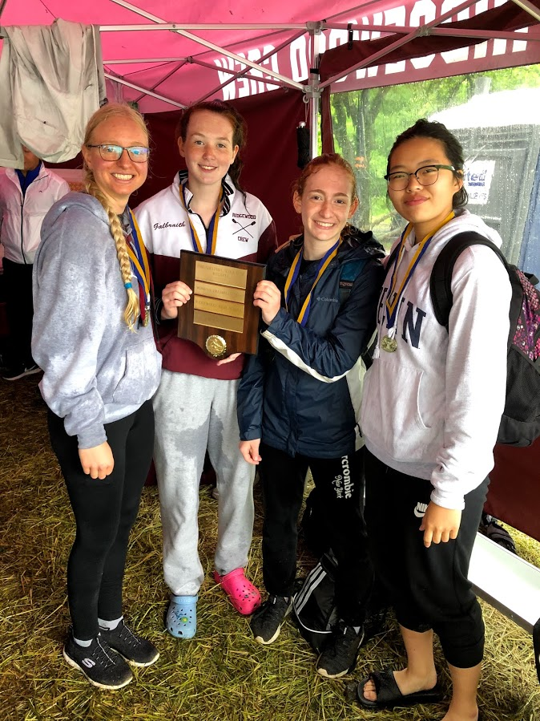
1Photo by Charlotte Villemoes
4: Caroline Villemoes - 16 (RC)
3: Eva Galbraith - 15 (RC)
2: Isabel Lee - 15 (RC)
1: Llian Riedel - 15 (RC)
Boys Freshman 4x 5th place 5:08.520
4: Brendan Lintner - 15 (RC)
3: Tommy Gammer - 15 (RC)
2: Carlo D'Arpa - 15 (RC)
1: Peter Joseph - 15 (RC)
Girls JV 2x 2nd place 5:33.330
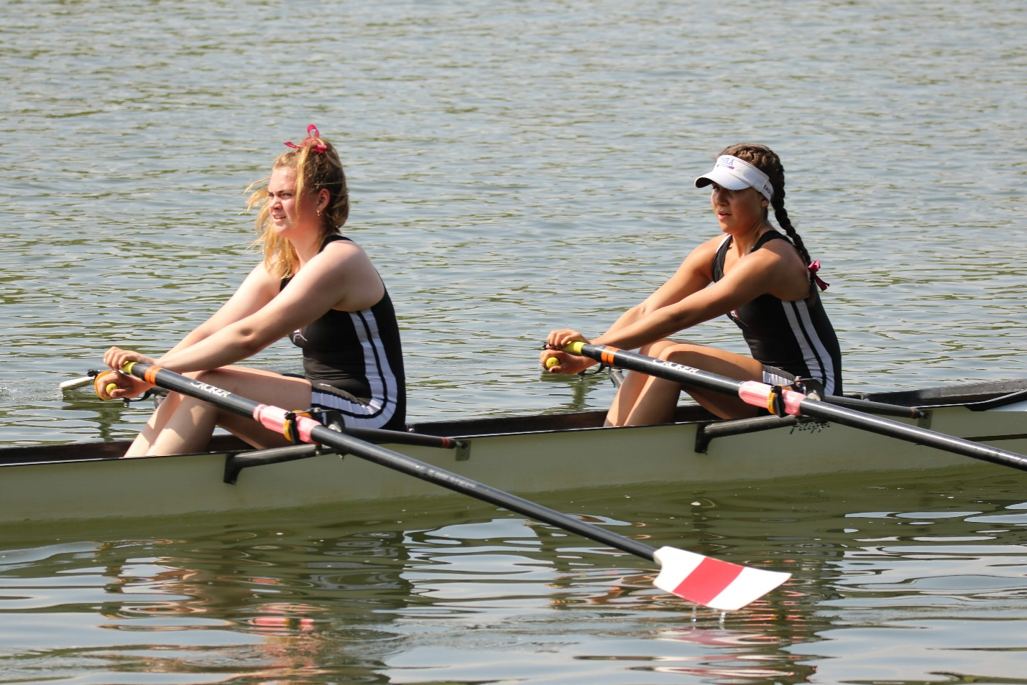
2Photo by Edward Hida
2: Hollis Sisco - 17 (RC)
1: Victoria Lyakerman - 16 (RC)

Girls JV 4x 1st place 5:01.260
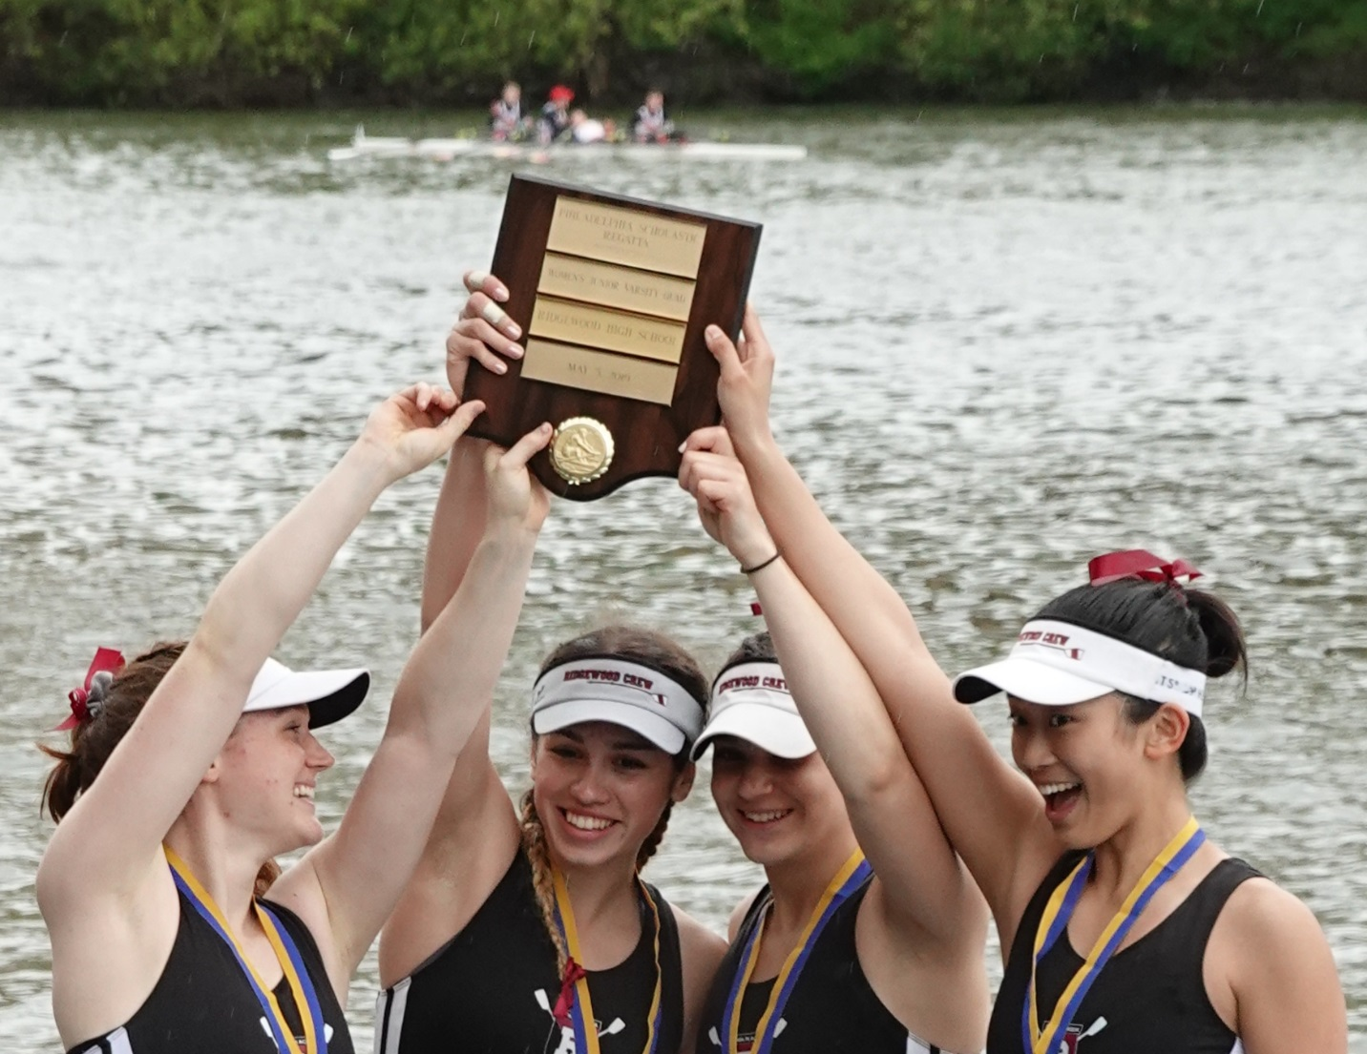
3Photo by Edward Hida
4: Anna Soderlund - 17 (RC)
3: Victoria Hoy - 16 (RC)
2: Lauren Sudol - 17 (RC)
1: Nicole Kye - 18 (RC)

Boys JV 4x 1st place 4:30.940
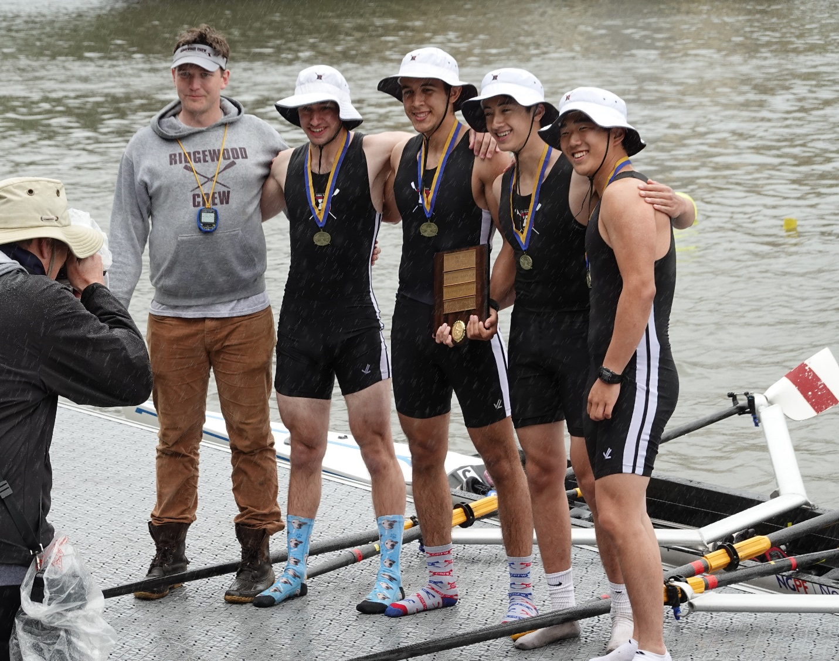

3Photo by Edward Hida
4: Tommy Montgomery - 18 (RC)
3: Gabriel Martinez - 17 (RC)
2: Matthew Lepis - 17 (RC)
1: Dylan Park - 18 (RC)

Boys JV 8+ 3rd place 4:31.030
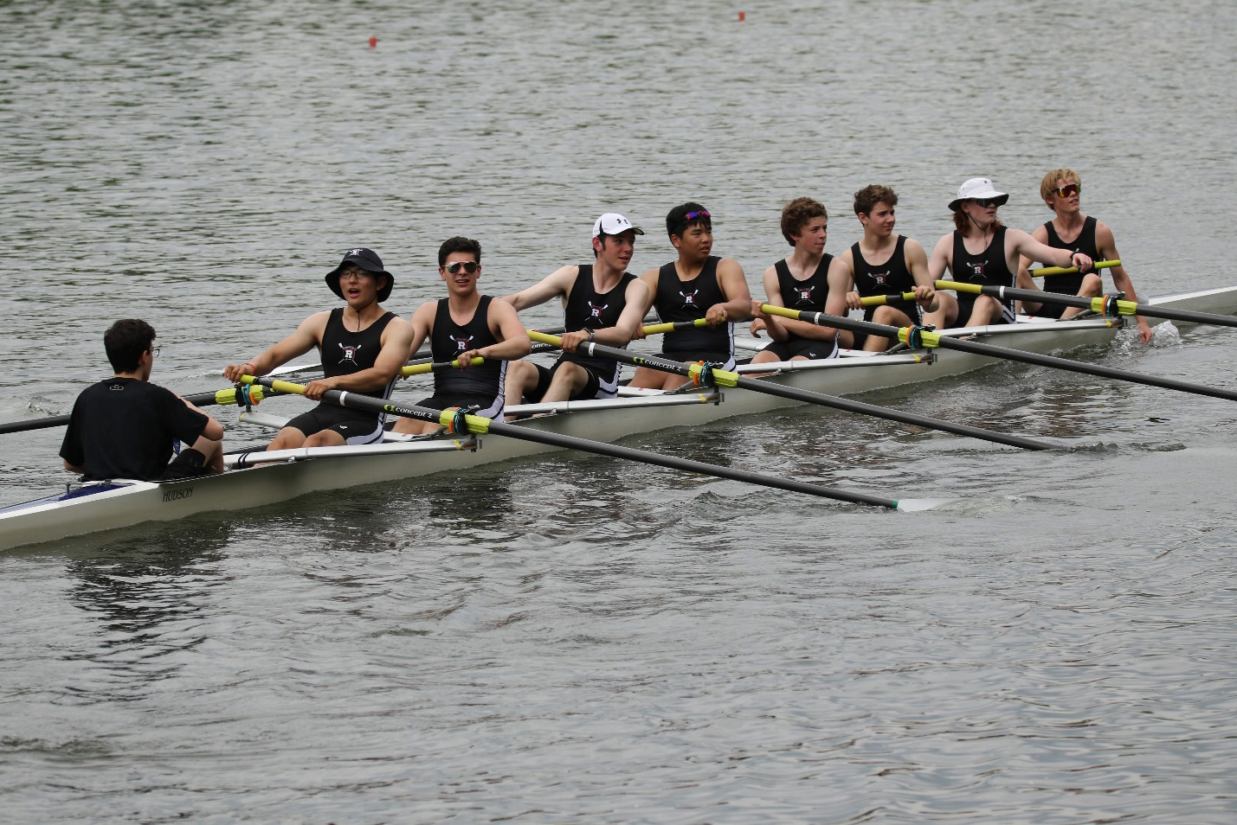
4Photo by Edward Hida
8: David Yang - 18 (RC)
7: Jake Andrews - 17 (RC)
6: Everest Galbraith - 17 (RC)
5: Yunjea Choi - 17 (RC)
4: Donn Patrick Joseph - 17 (RC)
3: Kyle Shattuck - 17 (RC)
2: Jonathan Hida - 16 (RC)
1: Thomas Woods - 16 (RC)
c: Daniel Lerner - 17 (RC)
Girls Ltwt 2x 4th place 5:44.170
2: Sara Wong - 16 (RC)
1: Alexandra Liu - 18 (RC)
Boys Ltwt 4x 5th place 4:52.750
4: Teagan Reinsdorf - 17 (RC)
3: Teddy Lowicki - 17 (RC)
2: Martin Carmona - 17 (RC)
1: Frank Orlando - 17 (RC)

Girls Varsity 4x 6th place 5:21.48
4: Diya Vij - 17 (RC)
3: Payton Kliesch - 16 (RC)
2: Kimberly Rahnefeld - 16 (RC)
1: Sofia Lee - 16 (RC)
Boys Varsity 4x 6th place 4:31.00
4: Drew Johnson - 18 (RC)
3: Alexander Saladucha - 19 (RC)
2: Alexander Melarti - 19 (RC)
1: Sebastian Rivero - 18 (RC)
Other Results:
Boys Freshman 2x Disqualified for interference in the Final
2: Ian Darby - 15 (RC)
1: Austin Kim - 16 (RC)
Boys JV 2x 5th place in the semifinals 5:27.710
2: Kaiyo Okamura - 17 (RC)
1: Francis Hamilton - 17 (RC)
Girls Freshman 8+ 9th place in the Time Trials 5:38.200
8: Lily Glenning - 16 (RC)
7: Serena Corcoran - 16 (RC)
6: Saira Shah - 15 (RC)
5: Sofia Kornemann - 15 (RC)
4: Salma Kahn - 15 (RC)
3: Dina Guemeryl - 15 (RC)
2: Erin Dowd - 15 (RC)
1: Eliza Howard - 15 (RC)
c: Victor Krivor - 15 (RC)
Boys JV 4+ 25th in the Time Trials 5:47.640
4: John LaFrance - 17 (RC)
3: Christopher Nuzzolo - 18 (RC)
2: James Scanlon - 16 (RC)
1: Jack Warren - 17 (RC)
c: Matthew Lee - 16 (RC)
With the rain out and cancellation of the Garden State Scholastic Championship in Camden, NJ on April 27th new qualifying events were established. It was determined that the first New Jersey boat to finish each race at the City Championship Regatta would advance to the Scholastic Rowing Association National Regatta on Dillon Lake, in Ohio over Memorial Day weekend, May 24th and 25th, 2019.

The advancing crews include the Girls LTWT 2x, Girls Freshman 4x, Girls Freshman 8+Girls JV 2x, Girls JV 4x, Boys JV 4x, Boys JV 8+ and Boys LTWT 4x. This is the first time in Ridgewood Crew history that a Boys JV 8+ has qualified for SRAA Nationals. This result at the City Championship ranks our crew the top Boys JV 8+ of the State of NJ.

The entire team is now in training for the upcoming Stotesbury Cup, the world’s largest high school regatta, scheduled for May 17 and 18 in Philadelphia, PA.

About Ridgewood Crew
Ridgewood Crew not only introduces participants to basic and advanced rowing techniques, but also instills and promotes character values including discipline, focus, teamwork and sportsmanship. Ridgewood Crew rowers are challenged individually and as a team. The philosophy of Ridgewood Crew is to elevate each athlete to the status of MVP. By doing so, we believe that a team of young leaders emerges. These leaders not only make fast boats, but also significant contributions toward their individual pursuits. Founded in 2004, the team rows on the Passaic River in northern NJ and competes in the sport’s premier regattas held throughout the Northeast.
In the program's short history, our youth, board and parent volunteers have moved Ridgewood Crew forward by leaps and bounds. That success is represented by the widespread individual and team achievements of each of the student-athletes on the roster. To facilitate that success, Ridgewood Crew continues to make investments in coaching and new equipment. The coaching staff is one of the most experienced in program history.
Ridgewood Crew athletes compete in the Philly Flicks on the Schuylkill River as well as at the highly competitive SRAA Nationals, Stotesbury Cup Regatta, Philadelphia City Championships, Passaic River Northern NJ Championships and Garden State Championships. Additionally, the team's overall performance continues to attract interest from top rowing colleges and universities including: Bucknell, Boston College, Boston University, Columbia University, Drexel, Duke, Fairfield, Fordham, George Mason, Georgetown, Harvard, Holy Cross, Lehigh, Marist, Notre Dame, Purdue, Syracuse, Trinity College, University of Delaware, University of North Carolina, University of Wisconsin, Williams, and others.
Ridgewood Crew offers Learn-To-Row and various development programs throughout the year for students as young as 7th grade to experience what Crew is all about. Come row with us!
For more information, to support or join the team, contact Ridgewood Crew at http://www.ridgewoodcrew.com and on Facebook at Ridgewood Crew!

###

