Ridgewood Crew girls dominate at Stotesbury, the largest high school rowing regatta in the world. Girls Varsity Double earned the Gold and the Lovey Farrell Cup, and the Girls Junior Varsity earned the Bronze. See below for more....

This weekend, Ridgewood Crew traveled to the Schuylkill River in Philadelphia for the legendary Stotesbury Cup Regatta. Stotesbury Cup is the largest scholastic regatta in the world and features approximately 5,000 high school athletes representing nearly 200 different schools in competition.

On Friday morning into the early afternoon, Ridgewood had 14 entries compete in time trials. Of the 14 crews, 11 advanced to the semi-final rounds held Friday afternoon and Saturday morning. To put the achievement in perspective, many crews were packing up their boats to leave after time trials on Friday.

In the semi-final round, Ridgewood was able to advance 8 crews to the finals for Saturday afternoon.

Crews that made semi-finals and finals are listed below:

Girls Junior Double: Alexandra Walton Roth,Maddie Gibson - Semi-finals, Finals (3rd) Boys Junior Double: Drew Johnson, Alex Melarti - Semi-finals Boys Freshman Quad: Tommy Montgomery, Gabe Martinez, David Yang, Dylan Park
- Semi-finals, Finals (6th) Girls Varsity Lightweight Double: Maddy Phillips, Emily Gilman - Semi-finals, Finals (5th) Boys Varsity Lightweight
Double: Sam Daspin, Spencer Campbell - Semi-finals, Finals (5th) Boys Junior
Quad: Ed Hida, Alex Saladucha, Joe O'Keefe, Henry Koontz - Semi-finals, Finals (4th) Girls Varsity Double: Claire Callaghan, Jordan Wittmaack - Semi-finals, Finals (1st) Boys Varsity Double: Patrick DuBois, Ian Soderlund
- Semi-finals Boys Varsity Single: Charlie Koontz - Semi-finals, Finals
(5th) Girls Varsity Quad: Isabella DeGregorio, Chloe Young, Amanda Perez, Melissa Dexter - Semi-finals, Finals (4th) Boys Varsity Quad: Sebastian Rivero, Andrew Felix, Matt Seiter, Walter Friedrich - Semi-finals

Saturday afternoon showcased the fastest scholastic rowers from places as far away as Florida, Texas, and Canada. Ridgewood was able to place two boats in medaling position. Ridgewood started off their first final with the Girls Junior Double with Alexandra Walton Roth and Maddie Gibson getting bronze medals. They showed true grit in the last 300 meters of the race to pass a hard charging Springside-Chestnut Hill crew.

Later on Saturday, the Girls Varsity Double of Claire Callaghan and Jordan Wittmaack blitzed the final 500 meters of the race going from 3rd or 4th place to first place for a gold medal finish. Seniors, both girls had received silver medals at Stotesbury Cup as Freshman and Sophomores, and were ecstatic to stand on the medal dock to receive their gold medals and the Lovey Farrell Cup Award for the category. Bridget Callaghan, Claire Callaghan's older sister won the same award two years ago with her partner, Julia Hefferon.

In all, Ridgewood Crew posted excellent results. As Head Coach Boris Roque-Alvarez said, "It was amazing that we were able to get so many crews into the semi-finals and finals, and we are proud of all of our athletes."

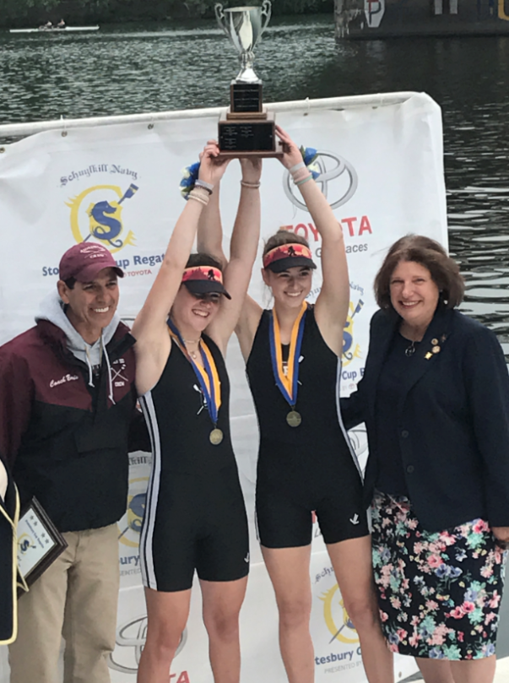
Gold Medal and Lovey Farrell Cup Awardees Claire Callaghan and Jordan Wittmaack Girls Varsity Double Photo:Terry Wittmaack

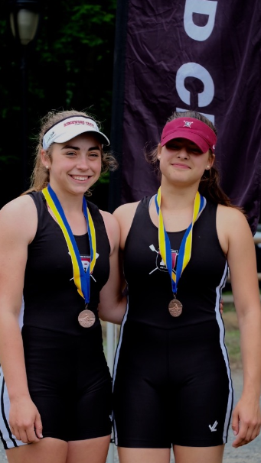
Bronze Medalists
Maddie Gibson and Alexandra Walton Roth
Girls JV Double
Photo: Nicole Gibson

