News for Immediate Release

Contact: Stacey Kliesch

201.655.4032

staceykliesch@gmail.com

Ridgewood Crew Succeeds at the Garden State Scholastic Championship Regatta
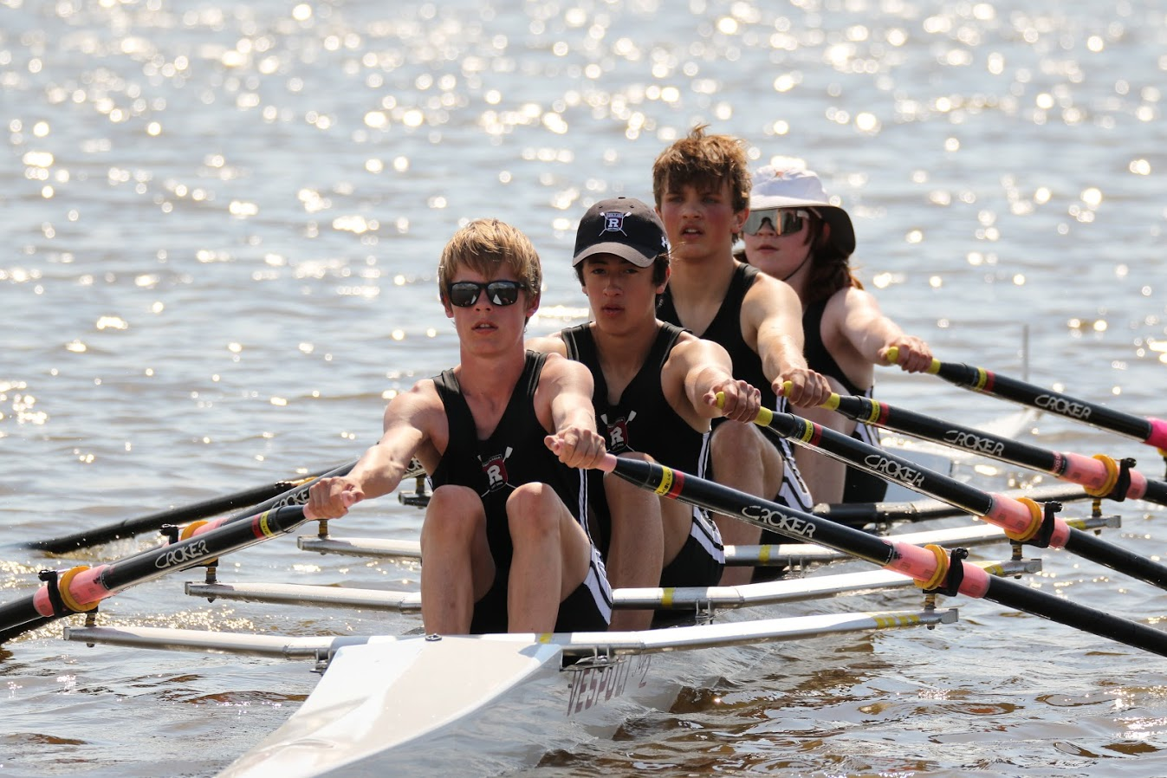
Figure 1 Photo of Thomas Woods, Matthew Lepis, Teddy Lowicki and Jonathan Hida by Ed Hida
Pennsauken, New Jersey, April 28, 2018 – Ridgewood Crew athletes traveled to the Cooper River this weekend to compete in the Garden State Scholastic Championship Regatta. The Coopers Training Center event was 1,500 meters, the first in a series of championship races the team competes in each spring. Winning teams qualify to compete at the Scholastic Rowing Association of America National Championships on May 25 and 26. This year's race included rowers from 41 NJ clubs. Ridgewood had the largest number of entrants at 16 boats in 15 categories.
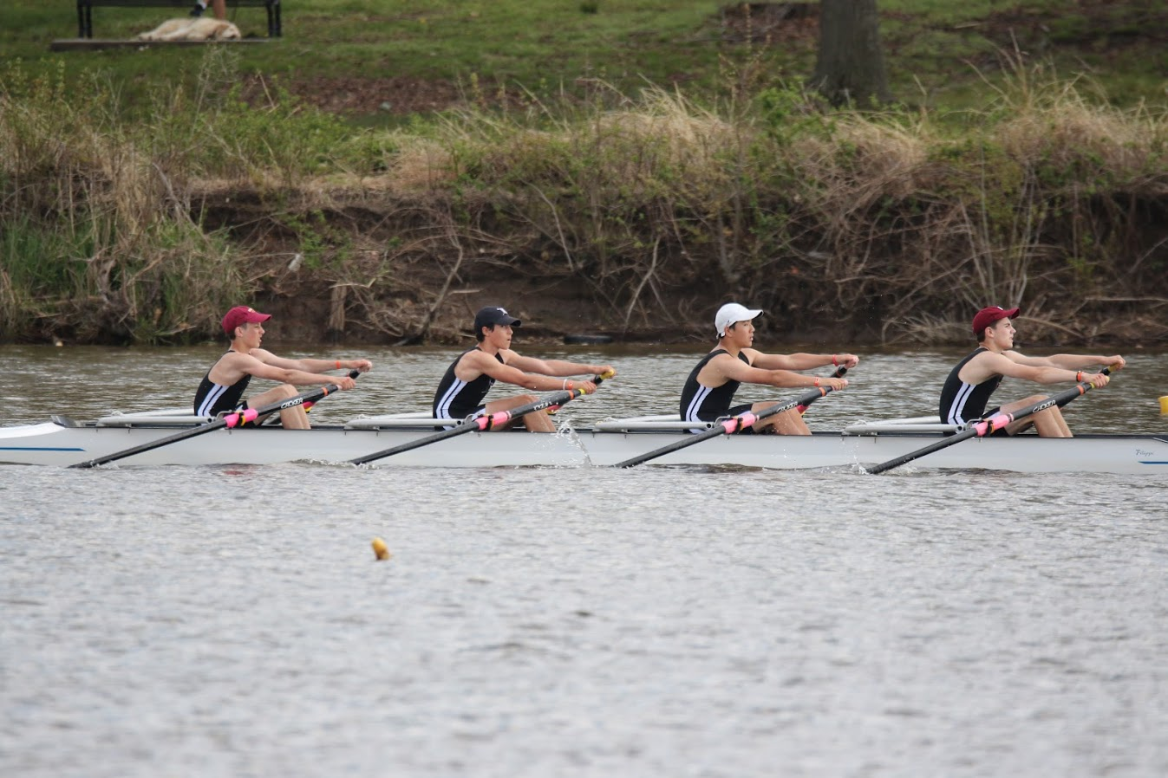
Figure 2 Photo of Kaiyo Okamura, Kyle Shattuck, Martin Carmona and Frank Orlando by Ed Hida
The surprises of the day included the Men’s Ltwt JV 4x who raced in the Men’s Ltwt Sr. 4x category and won first place. Sophomore Aidan Williamson, Women’s JV 1x, competed in the Women’s Sr. 1x category and placed fourth.
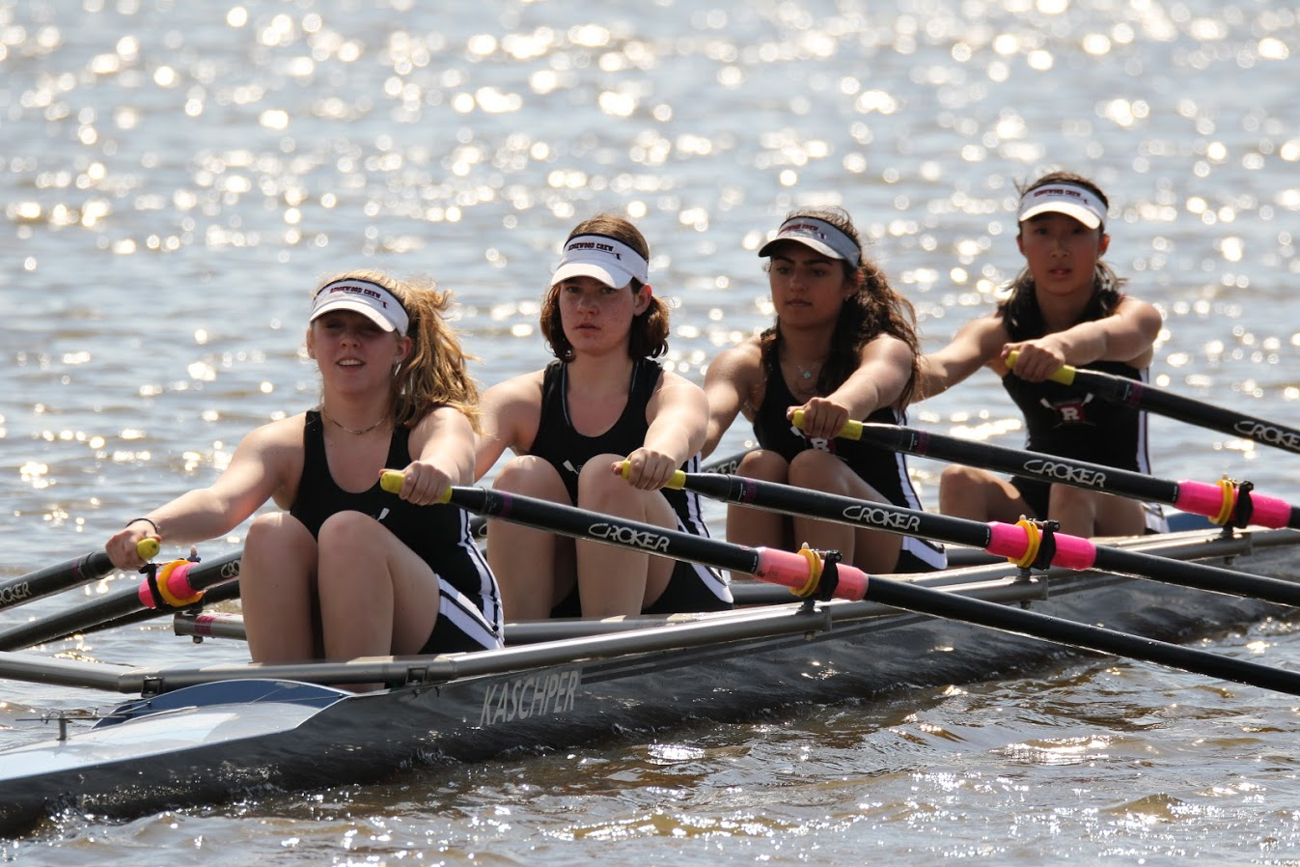
Figure 3 Photo of Jean-Marie Thomas, Payton Kliesch, Diya Vij and Sophia Lee by Ed Hida
Ridgewood Crew finished the day with an impressive 15 medals, with the following first place winners: Men’s Jr. 1x rowed by Gabriel Martinez; Men’s Ltwt 2x rowed by Joseph O’Keefe and Spencer Campbell; Women’s Sr. 2x rowed by Amanda Perry and Alexandra Walton Roth; Men’s Freshman 4x rowed by Thomas Woods, Matthew Lepis, Teddy Lowicki and Jonathan Hida; Women’s Novice 4x rowed by Jean-Marie Thomas, Payton Kliesch, Diya Vij and Sophia Lee; Women’s Jr. 4x rowed by Anna Soderlund, Hollis Sisco, Nicole Kye and Alexandra Liu; Men’s Jr. 4+ rowed by Alexander Melarti, Drew Johnson, Tommy Montgomery and Sebastian Rivero and the Men’s Ltwt Sr. 4x rowed by Kaiyo Okamura, Kyle Shattuck, Martin Carmona and Frank Orlando.
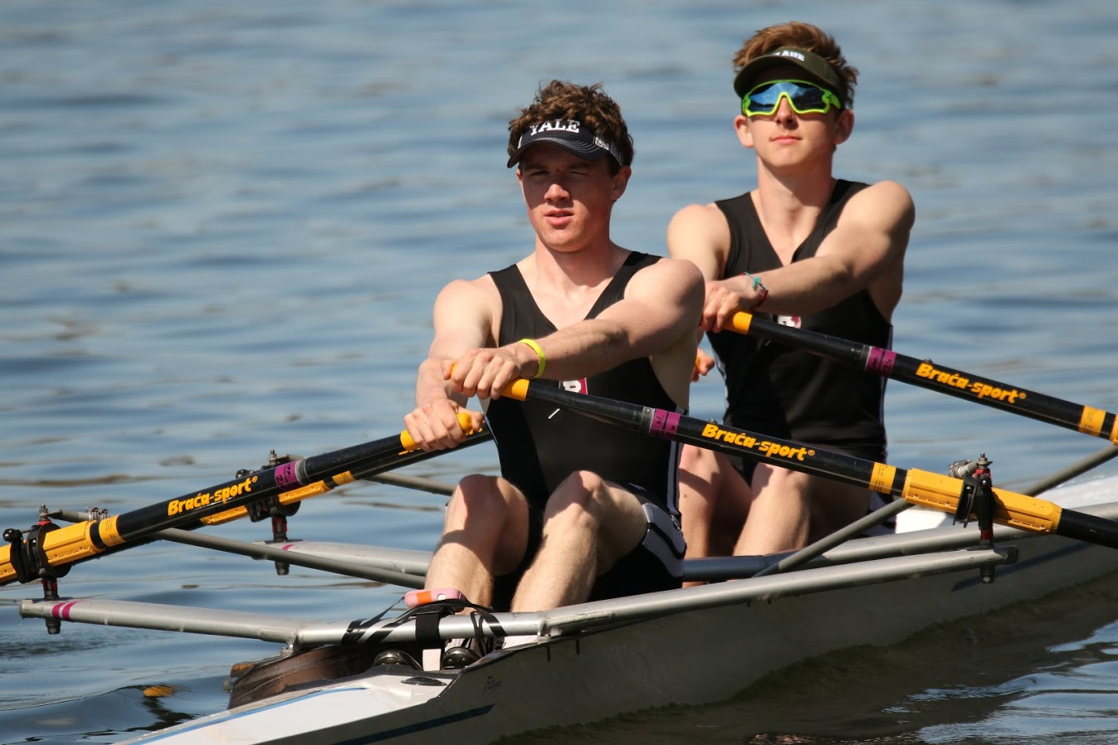
Figure 4 Photo of Joseph O'Keefe and Spencer Campbell by Ed Hida
Ridgewood Crew also had four second place and one third place finish. In second place were the Men’s Sr. 1x rowed by Walter Friedrich; Men’s Jr. 2x rowed by David Yang and Dylan Park; Men’s Sr. 2x rowed by Edward Hida and Alexander Saladucha and the Women’s Freshman 4x rowed by Lauren Sudol, Victoria Hoy, Kimberly Rahnefeld and Victoria Lyakerman. Maddie Gibson had a third-place finish in the Women’s Sr. 1x race.
Our coaches and athletes hope to build off of this weekend’s success when they compete in the City Championships in Philadelphia on May 5th and 6th.

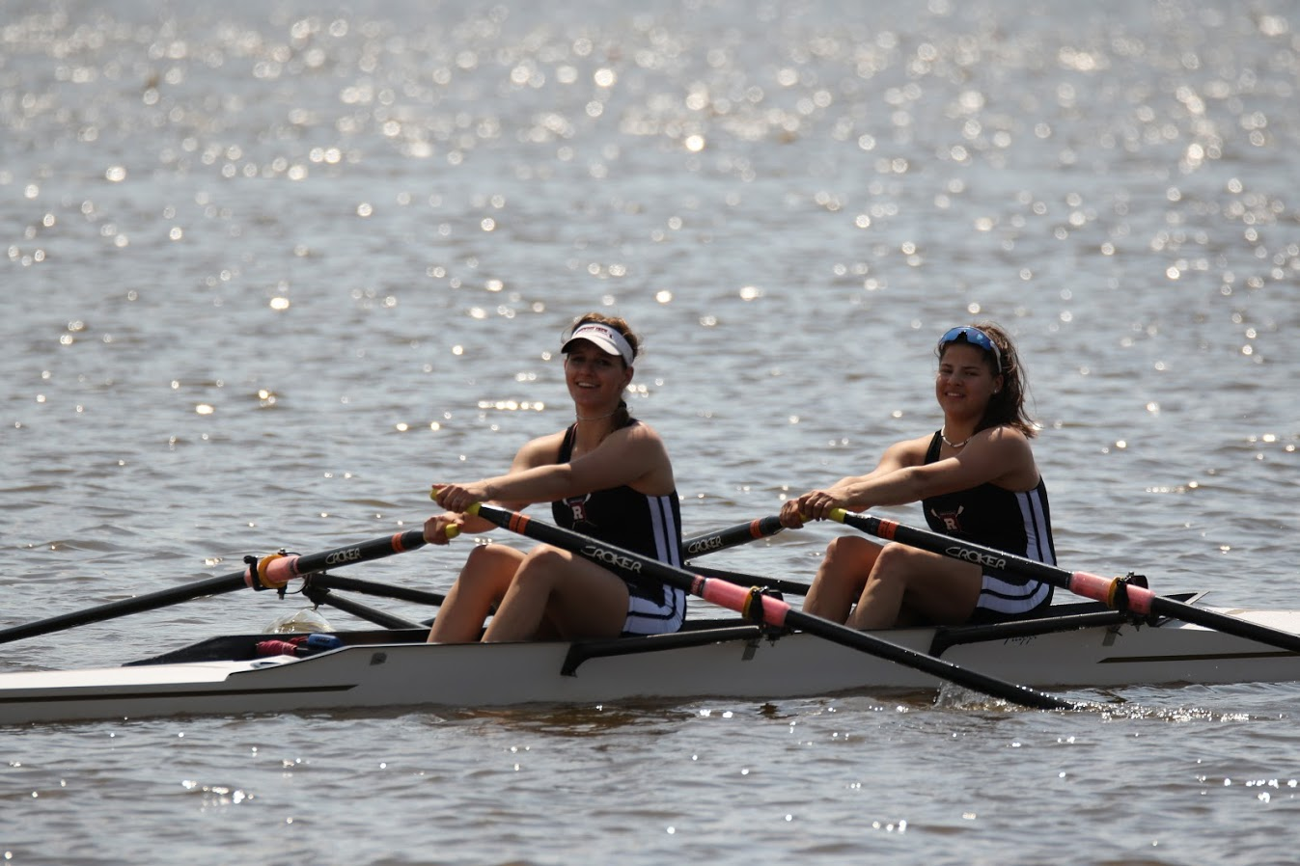
Figure 5 Photo of Amanda Perry and Alexandra Walton Roth by Ed Hida
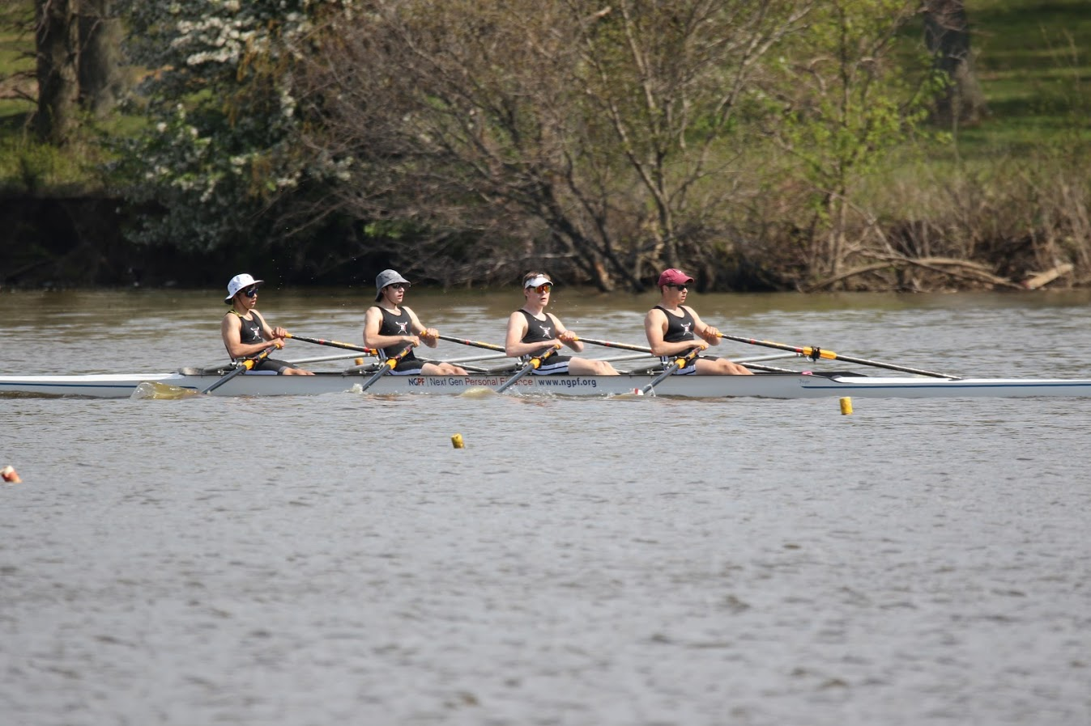
Figure 6 Photo of Alexander Mularti, Drew Johnson, Tommy Montgomery and Sebastian Rivero by Ed Hida
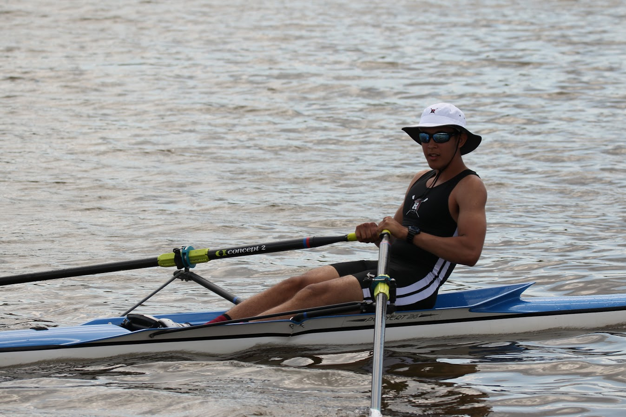
Figure 7 Photo of Gabriel Martinez by Ed Hida
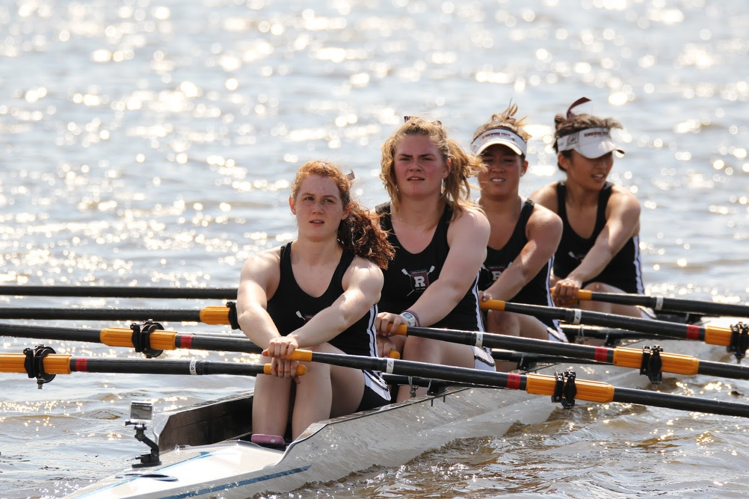
Figure 8 Photo of Anna Soderlund, Hollis Sisco, Nicole Kye and Alexandra Liu by Ed Hida
About Ridgewood Crew
Ridgewood Crew not only introduces participants to basic and advanced rowing techniques, but also instills and promotes character values including discipline, focus, teamwork and sportsmanship. Ridgewood Crew rowers are challenged individually and as a team. The philosophy of Ridgewood Crew is to elevate each athlete to the status of MVP. By doing so, we believe that a team of young leaders emerges. These leaders not only make fast boats, but also significant contributions toward their individual pursuits.
Ridgewood Crew introduces Ridgewood, NJ high school-aged youth to the traditions, athleticism, sportsmanship, techniques and camaraderie of the sport of rowing. Founded in 2004, the team rows on the Passaic River in northern NJ and competes in the sport’s premier regattas held throughout the Northeast.
In the program's short history, our youth, board and parent volunteers have moved Ridgewood Crew forward by leaps and bounds. That success is represented by the widespread individual and team achievements of each of the student-athletes on the roster. To facilitate that success, Ridgewood Crew continues to make investments in coaching and new equipment. The coaching staff is one of the most experienced in program history.
Ridgewood Crew athletes compete in the Philly Flicks on the Schuylkill River as well as at the highly competitive SRAA Nationals, Stotesbury Cup Regatta, Philadelphia City Championships, Passaic River Northern NJ Championships and Garden State Championships. Additionally, the team's overall performance continues to attract interest from top rowing colleges and universities including: Bucknell, Boston College, Boston University, Columbia University, Drexel, Duke, Fairfield, Fordham, George Mason, Georgetown, Harvard, Holy Cross, Lehigh, Marist, Notre Dame, Syracuse, Trinity College, University of Delaware, Williams, and others. The program also celebrated its first female athlete to receive a full, four-year rowing scholarship.
Ridgewood Crew offers several ways for you to experience our mission: join the team, volunteer or donate. Student athlete programs being with Learn-To-Row for middle school schoolers.
For more information, to support of join the team, contact Ridgewood at http://www.ridgewoodcrew.com
###

