News for Immediate Release

Contact: Stacey Kliesch

201.655.4032

staceykliesch@gmail.com

Ridgewood Crew Competes at the

Head of the Passaic Regatta

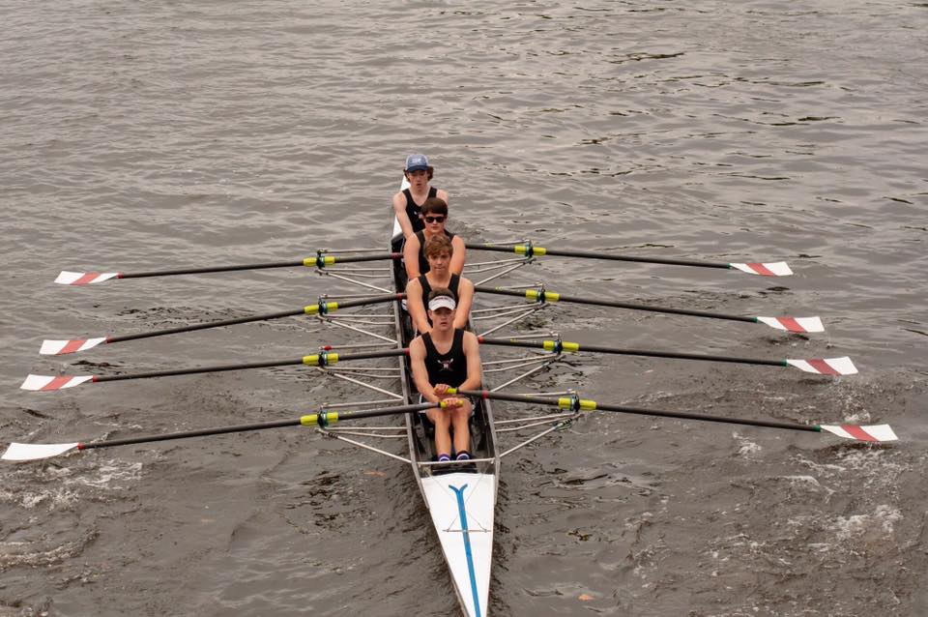
Jack Warren, Niko Carlson, John LaFrance and Francis Hamilton finish first
in the Mens HS Novice 4x. Photo by Dan LaFrance
Ridgewood, New Jersey, October 14, 2018 – Ridgewood Crew participated in a local event this past weekend at the 2018 Head of the Passaic Regatta led by Head Coach Boris Roque-Alvarez, veteran coach Bob O’Connor and two new coaches for the novices, Margaret Dudrear, and James Trunley. Margaret is a Drexel University graduate who previously worked as assistant coach for Conestoga Crew. James is a Delaware University graduate who trained under Coach Roque-Alvarez at Nereid Boat Club. Launching from their familiar Passaic River Rowing Association docks in Lyndhurst, NJ, 45 total teams took to the water with Ridgewood Crew competing with 19 entries.

“We were very happy with the results and the technical level shown by our rowers. We have started to see the results of the 8th Grade Development Program as Sunday, for the first time in RC history we have 14 Freshmen racing in the Fall with excellent results.”
~ Head Coach Boris Roque-Alvarez

~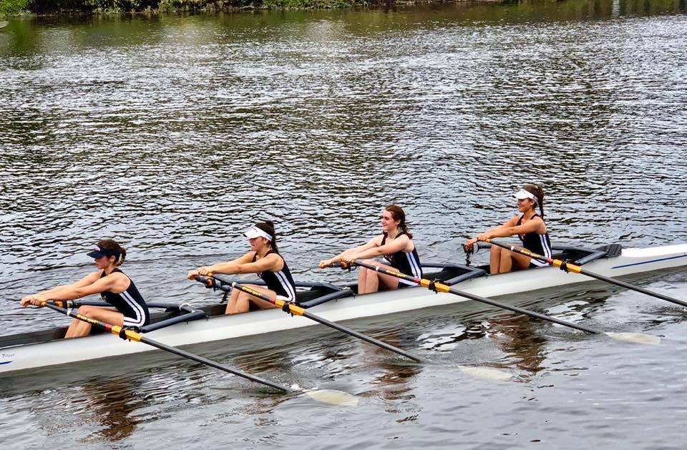
Victoria Hoy, Lauren Sudol, Anna Soderlund and Victoria Lyakerman
Take First Place in the Womens HS JV 4x. Photo by Janice Brier-Soderlund

The Top Finishers were:
Mens HS Varsity 4: 2nd Place Drew Johnson, Matthew Lepis, Teddy Lowicki, Dylan Park
Mens HS JV 4x: 2nd Place David Yang, Kyle Shattuck, Martin Carmona, Jonathan Hida
Mens HS 1x: 3rd Place Alexander Saladucha
Womens HS JV 4x: 1st Place Victoria Hoy, Lauren Sudol, Anna Soderlund, Victoria Lyakerman
Womens HS JV 2x: 3rd Place Alexandra Liu and Nicole Kye
Mens HS JV 2x: 3rd Place Thomas Woods and Kaio Okamura
Mens HS Novice 4x: 1st Place Jack Warren, Niko Carlson, John LaFrance, Francis Hamilton
2nd Place Tommy Gammer, Brendan Linter, Peter Joseph, Victor Krivor
Womens HS Novice 4x: 1st Place Llian Riedel, Caroline Villemoes, Larah Gutierrez-Camano,
Isabel Lee

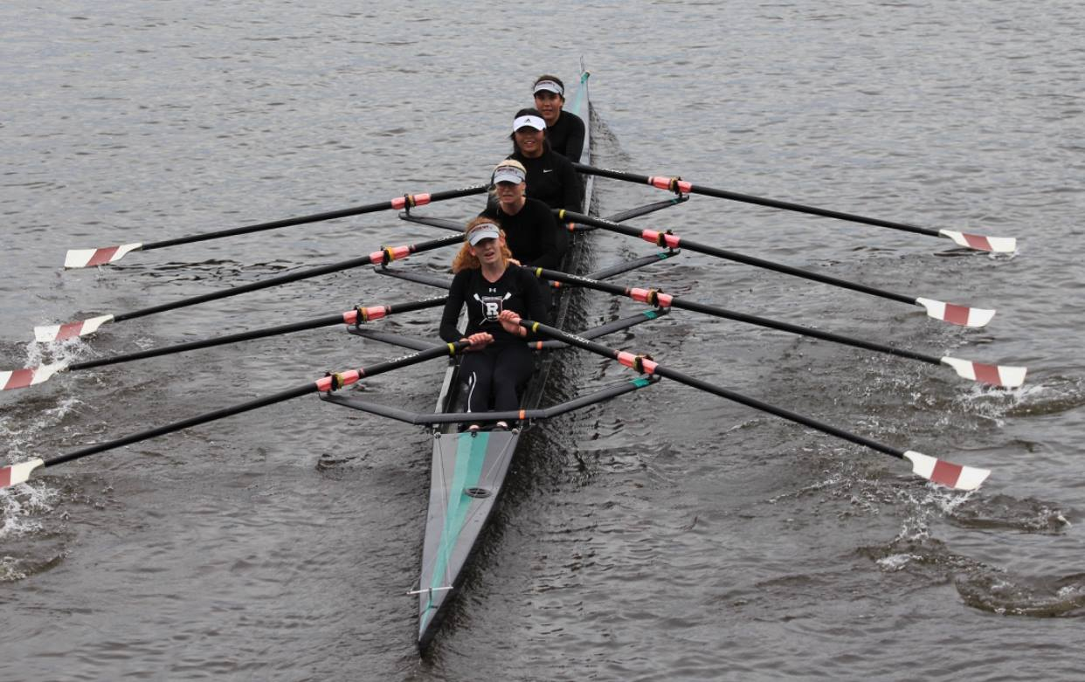
Llian Ridel, Caroline Villemoes, Isabel Lee and Larah Gutierrez-Camano Finish First
in the Womens HS Novice 4x. Photo by Charlotte Vestergren Villemoes
About Ridgewood Crew
Ridgewood Crew not only introduces participants to basic and advanced rowing techniques, but also instills and promotes character values including discipline, focus, teamwork and sportsmanship. Ridgewood Crew rowers are challenged individually and as a team. The philosophy of Ridgewood Crew is to elevate each athlete to the status of MVP. By doing so, we believe that a team of young leaders emerges. These leaders not only make fast boats, but also significant contributions toward their individual pursuits.
Ridgewood Crew introduces Ridgewood, NJ high school-aged youth to the traditions, athleticism, sportsmanship, techniques and camaraderie of the sport of rowing. Founded in 2004, the team rows on the Passaic River in northern NJ and competes in the sport’s premier regattas held throughout the Northeast.
In the program's short history, our youth, board and parent volunteers have moved Ridgewood Crew forward by leaps and bounds. That success is represented by the widespread individual and team achievements of each of the student-athletes on the roster. To facilitate that success, Ridgewood Crew continues to make investments in coaching and new equipment. The coaching staff is one of the most experienced in program history.
Ridgewood Crew athletes compete in the Philly Flicks on the Schuylkill River as well as at the highly competitive SRAA Nationals, Stotesbury Cup Regatta, Philadelphia City Championships, Passaic River Northern NJ Championships and Garden State Championships. Additionally, the team's overall performance continues to attract interest from top rowing colleges and universities including: Bucknell, Boston College, Boston University, Columbia University, Drexel, Duke, Fairfield, Fordham, George Mason, Georgetown, Harvard, Holy Cross, Lehigh, Marist, Notre Dame, Syracuse, Trinity College, University of Delaware, Williams, and others. The program also celebrated its first female athlete to receive a full, four-year rowing scholarship.
Ridgewood Crew offers several ways for you to experience our mission: join the team, volunteer or donate. Student athlete programs being with Learn-To-Row for middle school schoolers.
For more information, to support of join the team, contact Ridgewood at http://www.ridgewoodcrew.com ###

