News for Immediate Release

Contact: Stacey Kliesch

201.655.4032

staceykliesch@gmail.com

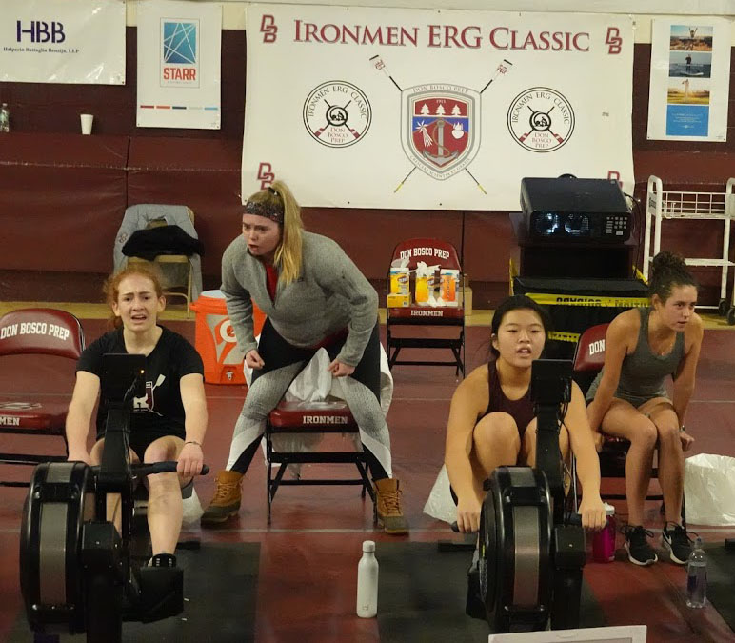
1 Silver Medalist Llian Riedel (L) and Gold Medalist Isabel Lee (R)
being encouraged by Coach Molly Dudrear (Center) Photo by Ed Hida

Ridgewood Crew Women Medal In Every Event They Enter!

Ridgewood, New Jersey, February 1, 2019 – The Ridgewood Crew team participated in the annual Ironman Erg Classic at Don Bosco Prep High School in Ramsey on January 26, 2019. The event attracted 21 clubs. Ridgewood Crew had 62 entries, second only to Montclair High School with 105.
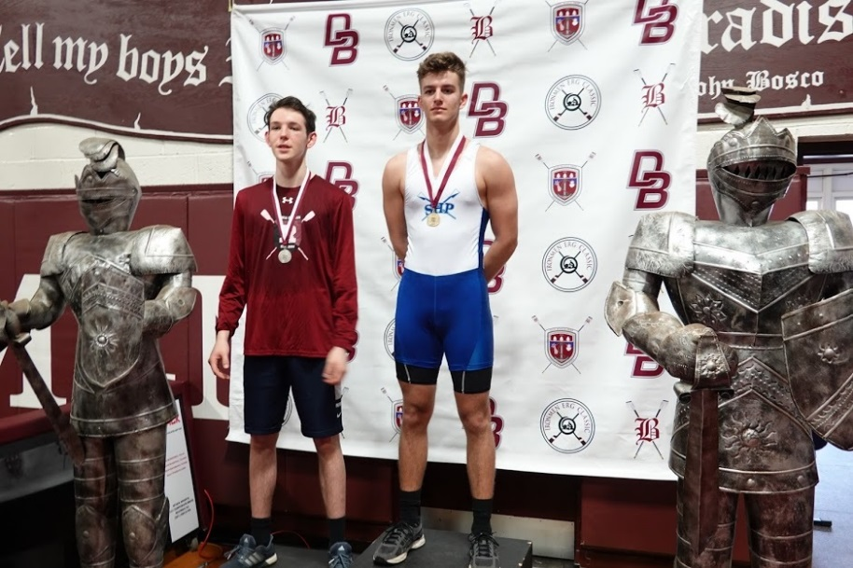
2 Silver Medalist Everest Galbraith (L) Photo by Ed Hida

Ridgewood performed well, particularly the female athletes. According to Head Coach Boris Roque-Alvarez, “We had some good results! The girls did great. They medaled in each event that we entered, starting with the 8th grade rowers.”

Award Winning Results included…

Event: Girls 8th Grade Silver Medalist Aleth Hamilton
Event: Womens’ High School Freshmen Gold Medalist Isabel Lee
Silver Medalist Llian Riedel
Event: Men’s High School Novice Silver Medalist Everest Galbraith
Event: Womens’ High School Lightweight Gold Medalist Lauren Sudol
Silver Medalist Victoria Hoy
Event: Womens’ High School Open Bronze Medalist Anna Soderlund

3 Bronze Medalist Anna Soderlund Photo by Ed Hida

The team’s success is a result of the hard work and dedication through the fall and winter practice seasons. First place winner Lauren Sudol said, “I have been training very hard so it felt incredible to not only set a personal record but to win. It was great to be on the podium with my teammate, Vicky Hoy. I look forward to a strong season and I can’t wait to get on the water.“

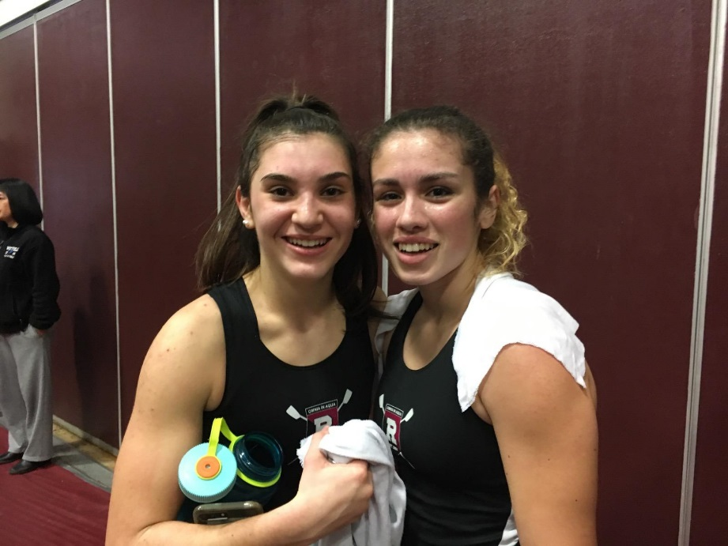
4 Gold Medalist Lauren Sudol (L) and Silver Medalist Victoria Hoy (R) Photo by Eliza Sudol

About Ridgewood Crew
Ridgewood Crew not only introduces participants to basic and advanced rowing techniques, but also instills and promotes character values including discipline, focus, teamwork and sportsmanship. Ridgewood Crew rowers are challenged individually and as a team. The philosophy of Ridgewood Crew is to elevate each athlete to the status of MVP. By doing so, we believe that a team of young leaders emerges. These leaders not only make fast boats, but also significant contributions toward their individual pursuits. Founded in 2004, the team rows on the Passaic River in northern NJ and competes in the sport’s premier regattas held throughout the Northeast.
In the program's short history, our youth, board and parent volunteers have moved Ridgewood Crew forward by leaps and bounds. That success is represented by the widespread individual and team achievements of each of the student-athletes on the roster. To facilitate that success, Ridgewood Crew continues to make investments in coaching and new equipment. The coaching staff is one of the most experienced in program history.
Ridgewood Crew athletes compete in the Philly Flicks on the Schuylkill River as well as at the highly competitive SRAA Nationals, Stotesbury Cup Regatta, Philadelphia City Championships, Passaic River Northern NJ Championships and Garden State Championships. Additionally, the team's overall performance continues to attract interest from top rowing colleges and universities including: Bucknell, Boston College, Boston University, Columbia University, Drexel, Duke, Fairfield, Fordham, George Mason, Georgetown, Harvard, Holy Cross, Lehigh, Marist, Notre Dame, Purdue, Syracuse, Trinity College, University of Delaware, University of North Carolina, University of Wisconsin, Williams, and others.
Ridgewood Crew offers several ways for you to experience our mission: join the team, volunteer or donate. Student athlete programs being with Learn-To-Row for middle school schoolers.
For more information, to support of join the team, contact Ridgewood at http://www.ridgewoodcrew.com
###

