News for Immediate Release

Contact: Stacey Kliesch

201.655.4032

staceykliesch@gmail.com

Ridgewood Crew takes on the 2018 Ironmen Erg Classic
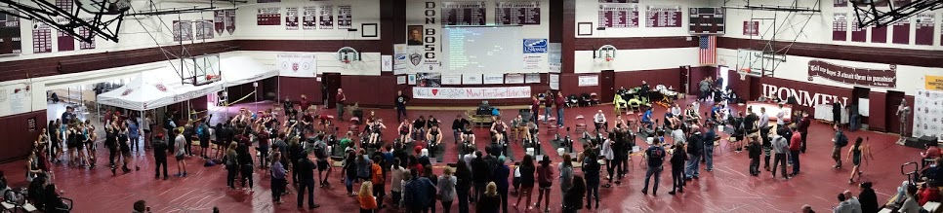
Ramsey, New Jersey, January 27, 2018 – Ridgewood Crew sent 63 athletes to test their fitness on Saturday at the Ironmen Erg Classic hosted by Don Bosco Prepatory High School. This year's race included rowers from 19 clubs across NJ, NY, PA and CT. At this event, all Ridgewood challengers produced effective results, with 45 competitors setting personal bests over the 2,000 meter distance on the indoor rowing machines. Ridgewood had the largest number of entrants after Montclair, with 67 entries.
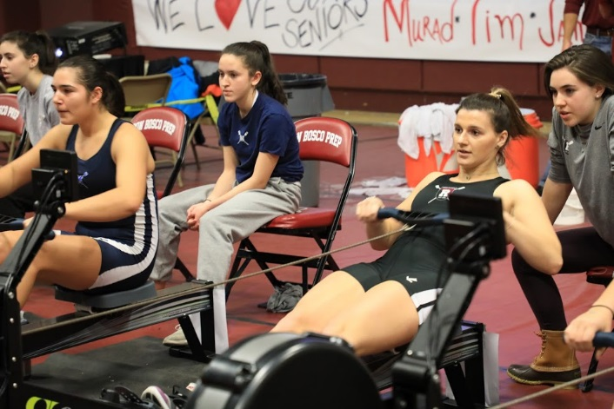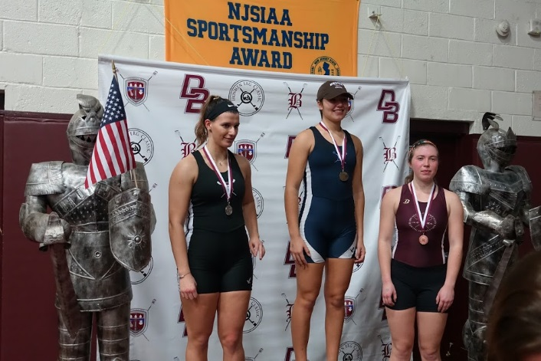
This year, it was athlete Amanda Perez in the Ridgewood Crew spotlight. Amanda took the Silver Medal in the Women’s High School Open competition, finishing between Gold Medalist Beate Kaz of Montclair High School and Josephine Grady of the Advanced Community Rowing Association.

About Ridgewood Crew
Ridgewood Crew not only introduces participants to basic and advanced rowing techniques, but also instills and promotes character values including discipline, focus, teamwork and sportsmanship. Ridgewood Crew rowers are challenged individually and as a team. The philosophy of Ridgewood Crew is to elevate each athlete to the status of MVP. By doing so, we believe that a team of young leaders emerges. These leaders not only make fast boats, but also significant contributions toward their individual pursuits.
Ridgewood Crew introduces Ridgewood, NJ high school-aged youth to the traditions, athleticism, sportsmanship, techniques and camaraderie of the sport of rowing. Founded in 2004, the team rows on the Passaic River in northern NJ and competes in the sport’s premier regattas held throughout the Northeast.
In the program's short history, our youth, board and parent volunteers have moved Ridgewood Crew forward by leaps and bounds. That success is represented by the widespread individual and team achievements of each of the student-athletes on the roster. To facilitate that success, Ridgewood Crew continues to make investments in coaching and new equipment. The coaching staff is one of the most experienced in program history.
Ridgewood Crew athletes compete in the Philly Flicks on the Schuylkill River as well as at the highly competitive SRAA Nationals, Stotesbury Cup Regatta, Philadelphia City Championships, Passaic River Northern NJ Championships and Garden State Championships. Additionally, the team's overall performance continued to attract interest from top rowing colleges and universities including: Bucknell, Boston College, Boston University, Columbia University, Drexel, Duke, Fairfield, Fordham, George Mason, Georgetown, Harvard, Holy Cross, Lehigh, Marist, Notre Dame, Syracuse, Trinity College, University of Delaware, Williams, and others. The program also celebrated its first female athlete to receive a full, four-year rowing scholarship.
Ridgewood Crew offers several ways for you to experience our mission: join the team, volunteer or donate.
For more information, to support of join the team, contact Ridgewood at http://www.ridgewoodcrew.com
###

