News for Immediate Release

Contact: Stacey Kliesch

201.655.4032

staceykliesch@gmail.com

1 Hollis Sisco and Victoria Lyakerman of the Girls JV 2x

Ridgewood Crew Perform Impressively

at the 2019 5th Manny Flick

Ridgewood, New Jersey, April 17, 2019 – For the third week in a row, the Ridgewood Crew athletes took to the water, this time for the final event in the pre-season series. Sunday, April 14, 2019, on the Schuylkill River in Philadelphia, 85 rowing clubs gathered to compete in the 5th Manny Flick. Ridgewood had 15 boats race in 13 events. Award Winning Results included…
4th Place: Boys Freshmen/ Novice 2x I. Darby, A. Kim
2nd Place: Boys Freshmen 4x B. Lintner, T. Gammer, C. D’Arpa, P. Joseph
8th Place: Boys JV 2x K. Okamura, F. Orlando
17th Place: Boys JV 4+ J. LaFrance, C. Nuzzolo, J. Scanlon, J. Warren, M. Lee (cox)
1st Place: Boys JV 4x T. Montgomery, G. Martinez, M. Lepis, D. Park
4th Place: Boys JV 8+ D. Yang, J. Andrews, E. Galbraith, Y. Choi, D. Joseph, F. Hamilton, J. Hida, T. Reinsdorf, D. Lerner (cox)
3rd Place: Boys Ltwt 4x K. Shattuck, T. Lowicki, T. Woods, M. Carmona
4th Place: Boys Varsity 4x A. Melarti, D. Johnson, A. Saladucha, S. Rivero

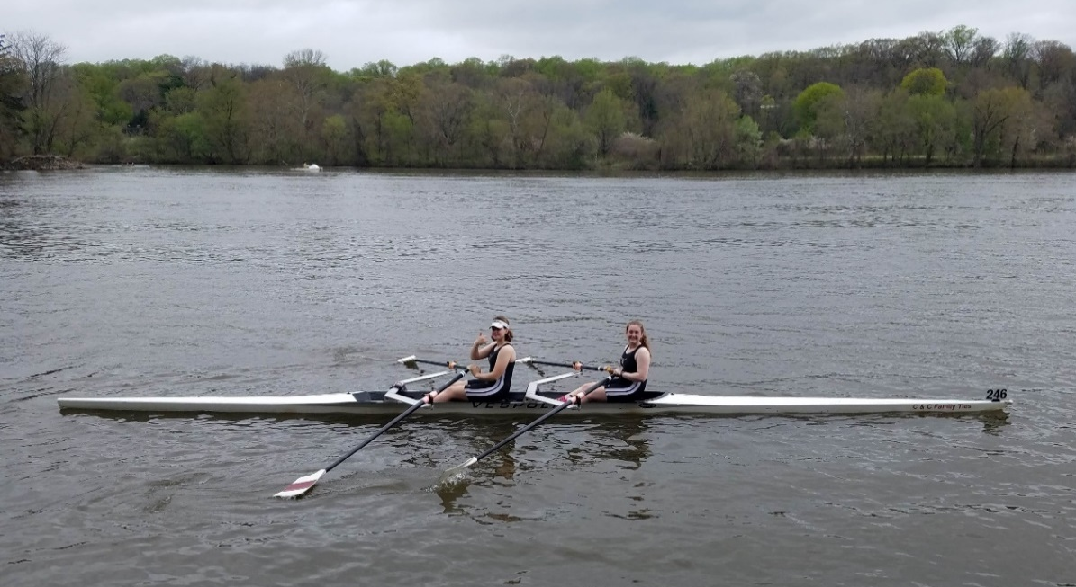
2 Payton Kliesch and Kimberly Rahnefeld of the Girls JV 2x

1st Place: Girls Freshmen 4x L. Riedel, C. Villemoes, E. Galbraith, I. Lee

8th Place: Girls Freshman 8+ L. Glenning, S. Corcoran, S. Shah, S. Kornemann, S. Kahn, D. Guemeryl, E. Dowd, E. Howard, V.Krivor (cox)
3rd Place: Girls JV 2x H. Sisco, V. Lyakerman
7th Place: Girls JV 2x P. Kliesch, K. Ravenfeld
1st Place: Girls JV 4x A. Soderlund, L. Sudol, V. Hoy, N. Kye
4th Place: Girls Ltwt 2x S. Wong, A. Liu
5th Place: Girls Ltwt 2x D. Vij, S. Lee

3 Sara Wong and Alexis Liu of the Girls Ltwt 2x

The Ridgewood Crew athletes are spending their Spring Break training 4 hours a day to prepare for the Garden State Scholastic Championship in Camden, NJ on April 27th.

About Ridgewood Crew
Ridgewood Crew not only introduces participants to basic and advanced rowing techniques, but also instills and promotes character values including discipline, focus, teamwork and sportsmanship. Ridgewood Crew rowers are challenged individually and as a team. The philosophy of Ridgewood Crew is to elevate each athlete to the status of MVP. By doing so, we believe that a team of young leaders emerges. These leaders not only make fast boats, but also significant contributions toward their individual pursuits. Founded in 2004, the team rows on the Passaic River in northern NJ and competes in the sport’s premier regattas held throughout the Northeast.
In the program's short history, our youth, board and parent volunteers have moved Ridgewood Crew forward by leaps and bounds. That success is represented by the widespread individual and team achievements of each of the student-athletes on the roster. To facilitate that success, Ridgewood Crew continues to make investments in coaching and new equipment. The coaching staff is one of the most experienced in program history.
Ridgewood Crew athletes compete in the Philly Flicks on the Schuylkill River as well as at the highly competitive SRAA Nationals, Stotesbury Cup Regatta, Philadelphia City Championships, Passaic River Northern NJ Championships and Garden State Championships. Additionally, the team's overall performance continues to attract interest from top rowing colleges and universities including: Bucknell, Boston College, Boston University, Columbia University, Drexel, Duke, Fairfield, Fordham, George Mason, Georgetown, Harvard, Holy Cross, Lehigh, Marist, Notre Dame, Purdue, Syracuse, Trinity College, University of Delaware, University of North Carolina, University of Wisconsin, Williams, and others.
Ridgewood Crew offers Learn-To-Row and various development programs throughout the year for students as young as 7th grade to experience what Crew is all about. Come row with us!
For more information, to support or join the team, contact Ridgewood Crew at http://www.ridgewoodcrew.com and on Facebook at Ridgewood Crew!

###

