News for Immediate Release

Contact: Stacey Kliesch

201.655.4032

staceykliesch@gmail.com

Ridgewood Crew Finishes With Three Gold Medals and Advances to Nationals!
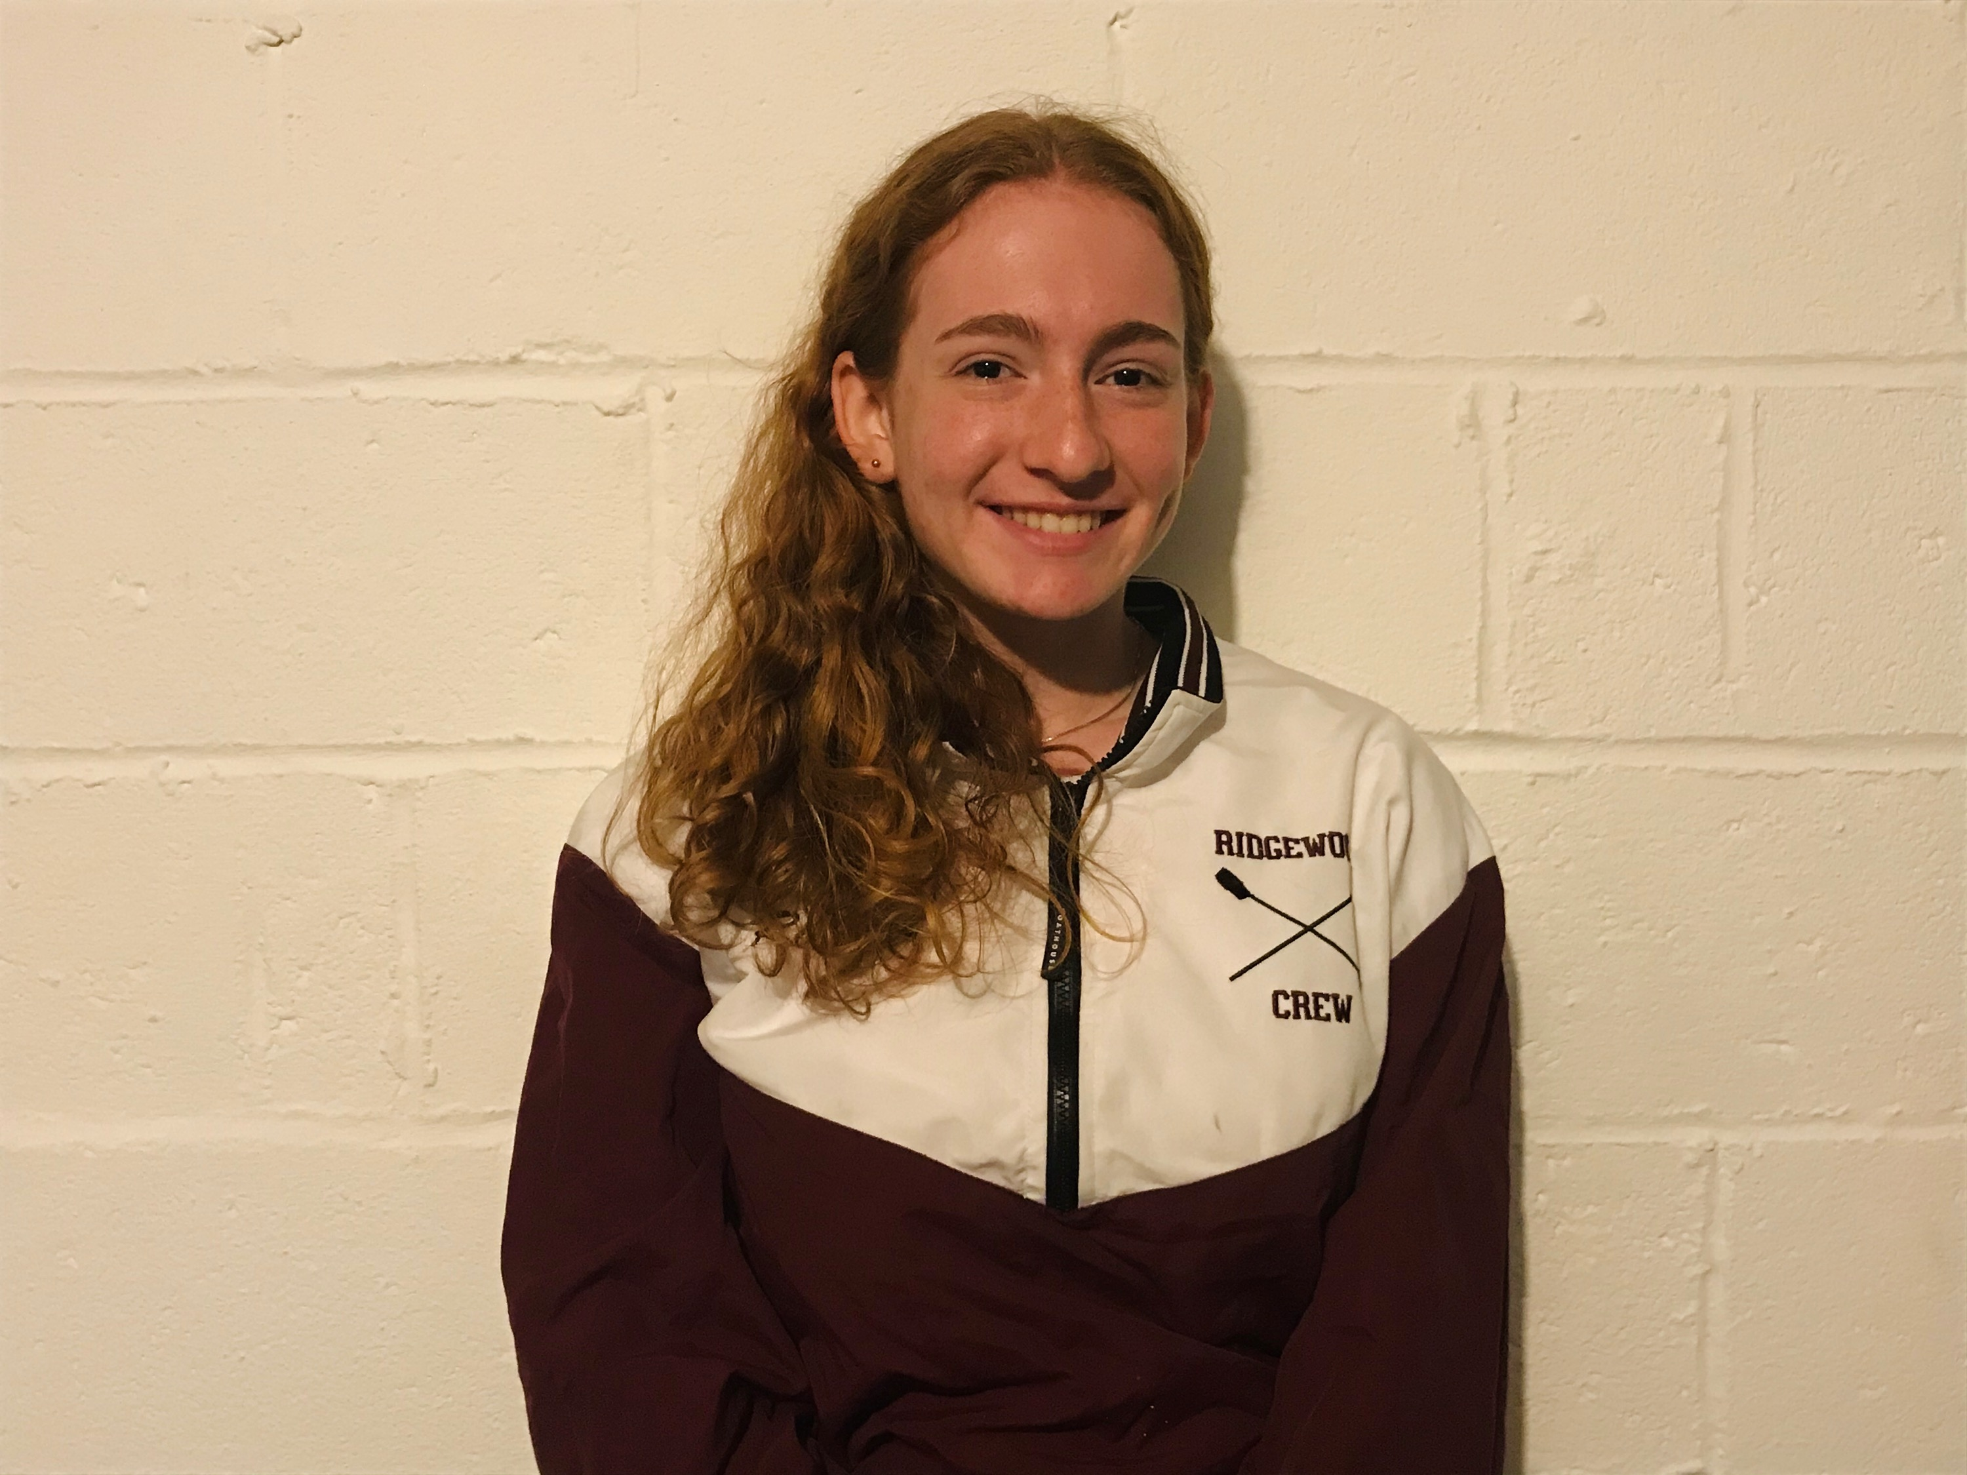
Llian Riedel, 2020 USRowing Virtual Youth Nationals Qualifier

Ridgewood, NJ May 17, 2020 – This weekend, Ridgewood Crew competed in the last of four races in the North Jersey Virtual Scrimmage Series. Ten clubs participated in the program, with 165 entries total. Ridgewood Crew had eleven athletes participate, resulting in three gold medals and one silver.
The North Jersey Virtual Scrimmage Series was offered for the first time this year after the season was cancelled due to COVID-19. This Ridgewood Crew’s results this week were as follows:

Mens HS 2000m 1x Ian Darby 4th Place 6:48.000
Farres Kamel 7th Place 7:25.000
Womens HS 2000m 1x Llian Riedel 1st Place 7:42.000
Caroline Villemoes 5th Place 8:05.000
Men 1500m 1x Ian Darby 1st Place 4:58.000
Mens Novice 1x 1500m Thomas Clark 5th Place 6”00.00
Ariel Reyes 6th Place 7:17.00
Womens 1x 1500m Llian Riedel 2nd Place 5:45.000
Womens Novice 1x Cadence Ignoffo 6th Place 7:09.000
Womens 1x 500m Dash Victoria Hoy 1st Place 1:43.000
Mens HS Novice 1x 500m Dash Henry Hersperger 6th Place 1:45.000

Additionally, the results are in for the USRowing Virtual Youth Mid-Atlantic Championship. Ridgewood Crew had 3 rowers participating:

- Womens U17 Llian Riedel finished in 2nd place with a time: 7:42
- Mens U17 Ian Darby finished in 4th place with a time: 6:48
- Women’s LTWT Caroline Villemoes finished in 5th place with a time: 8:05

These results officially qualify Llian Riedel to participate at the upcoming 2020 USRowing Virtual Youth Nationals.

Scrimmage One Results:

Individual results:
-Men’s 1x: 2nd Place, James Scalon, (4:59)
-Men’s Novice 1x: 7th Place, Michael Manevich, (5:58)
-Men’s Novice 4x: 2nd Place, Farres Kamel, Henry Hersperger, Thomas Clark, Jack Swartz, (5:43)
-Women’s 2x: 1st Place, Llian Riedel, Caroline Villemoes, (5:48)
-Women Novice 2x: 2nd Place, Cadence Ignoffio, Anna Mevissen, (6:46)
-Men’s 1x Dash: 1st Place, Gabriel Martinez (1:27)
-Women’s 1x Dash: 1st Place, Victoria Hoy (1:45)
-Men’s Novice 1x Dash: 5th Place, Kamel Farres (1:47)
6th Place, Jaime Papin (1:53)

Scrimmage Two Results:

Individual results:
-Men’s HS 1x: 3rd Place, Ian Darby, (5:03)
-Women’s 4x: 1st Place, Lilan Riedel, Victoria Hoy, Eva Galbraith, Caroline Villemoes (5:47)
-Women’s Novice 1x: 5th Place, Kate Hoffman (7:23)
-Women’s Novice 2x: 2nd Place, Olivia Kim, Skylar Kliesch (6:18)
-Men’s 1x 500m Dash: 2nd Place, Matthew Lepis (1:29)
4th Place, Everest Galbraith (1:30)
6th Place, James Scanlon (1:31)
9th Place, Thomas Woods (1:36)
-Women’s 1x 500m Dash: 1st Place, Victoria Hoy (1:43)
2nd Place, Lilan Riedel (1:44)
4th Place, Jasmine Parpel (1:47)
7th Place, Sara Wong (1:53)
-Men’s HS Novice 1x 500m: 2nd Place, Farres Kamel (1:35)
9th Place, Thomas Cheng (1:48)
10th Place, Ariel Reyes (1:49)
-Women’s HS Nov. 1x 500m 4th Place, Cadence Ignoffo (2:08)
-Men’s HS 1x Cox 500m 1st Place, Matthew Lee (1:46)

Scrimmage Three Results:

Individual results:
-Men’s 1x: 2nd Place, Ian Darby, (5:01)
-Women’s Novice 1x: 6th Place, Anna Mevissen, (6:50)
7th Place, Juliana Frattini, (7:16)
-Men’s HS Nov1x 500m Dash 6th Place, Sam Boogaert, (1:55)
-Women’s HS Nov1x 500m Dash: 4th Place, Skylar Kliesch, (1:58)
14th Place, Cadence Ignoffo, (2:09)

In the US, over 1 million high school kids play football or run track and field. Nearly 1 million play basketball. Soccer clocks in with over 800,000 players.
As few as 40,000 high school athletes row in the United States. Your child can be one of them.
Ridgewood Crew, founded in 2004, is a local rowing team coached by the most experienced staff in program history.

- Rowing is easy to learn. Kids do not need years of experience in the sport, or any other sport, to be successful on the team.

- Rowing provides a total body, aerobic workout with practice opportunities available year-round. Physiologically, rowers are superb examples of physical conditioning.

- Rowing is an outstanding team sport with crews assigned by the coaches for the best possible outcome. Popularity is not the route to success. Ridgewood Crew has no “star quarterback” but rather success is built on collective hard work, dedication to practice, and perseverance.

- In the United States, men and women row in nearly equal numbers, with outstanding opportunities to earn scholarships and continue the sport in college and beyond.

- Athletes of this non-contact sport have significantly less injuries than other sports.

Joining the Ridgewood Crew Team requires athletes in grades 8-12 to complete the Learn To Row program in advance of registering to try out. This includes a completing a swim test and one weekend intensive rowing clinic on the water. Please visit our website for more information, to review our schedule and register.
http://www.ridgewoodcrew.com/

Ridgewood Crew is lining up arrangements to return to the water as soon as New Jersey lifts the current Stay-At-Home order and it is safe to do so. All parties interested in joining Ridgewood Crew should investigate the Learn To Row Program on our website: http://www.ridgewoodcrew.com

About Ridgewood Crew
Ridgewood Crew not only introduces participants to basic and advanced rowing techniques, but also instills and promotes character values including discipline, focus, teamwork and sportsmanship. Ridgewood Crew rowers are challenged individually and as a team. The philosophy of Ridgewood Crew is to elevate each athlete to the status of MVP. By doing so, we believe that a team of young leaders emerges. These leaders not only make fast boats, but also significant contributions toward their individual pursuits. Founded in 2004, the team rows on the Passaic River in northern NJ and competes in the sport’s premier regattas held throughout the Northeast.
In the program's short history, our youth, board and parent volunteers have moved Ridgewood Crew forward by leaps and bounds. That success is represented by the widespread individual and team achievements of each of the student-athletes on the roster. To facilitate that success, Ridgewood Crew continues to make investments in coaching and new equipment. The coaching staff is one of the most experienced in program history.
In our typical season, Ridgewood Crew athletes compete in the Philly Flicks on the Schuylkill River as well as at the highly competitive SRAA Nationals, Stotesbury Cup Regatta, Philadelphia City Championships, Passaic River Northern NJ Championships and Garden State Championships. Additionally, the team's overall performance continues to attract interest from top rowing colleges and universities including: Bucknell, Boston College, Boston University, Columbia University, Drexel, Duke, Fairfield, Fordham, George Mason, Georgetown, Harvard, Holy Cross, Lehigh, Marist, Notre Dame, Purdue, Syracuse, Trinity College, University of Delaware, University of North Carolina, University of Wisconsin, Williams, and others.
Ridgewood Crew offers Learn-To-Row and various development programs throughout the year for students as young as 7th grade to experience what Crew is all about. Come row with us!
For more information, to support or join the team, contact Ridgewood Crew at http://www.ridgewoodcrew.com and on Facebook at Ridgewood Crew!

###

