News for Immediate Release

Contact: Stacey Kliesch

201.655.4032

staceykliesch@gmail.com

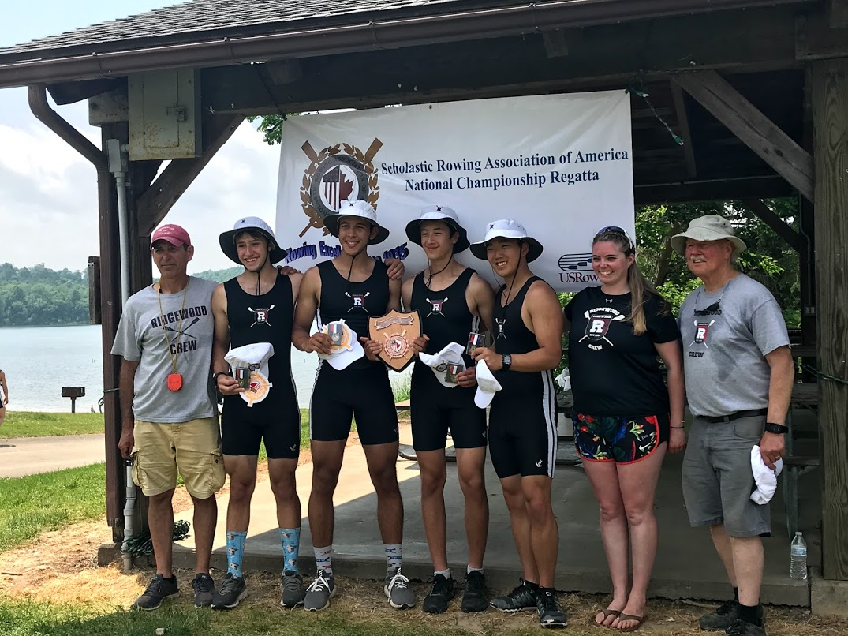
1 JV Boys 4x Capture the Gold with Head Coach Boris Roque-Alvarez, Assistant Coaches Molly Dudrear and Bob O’Connor!

Ridgewood Crew Wins Silver and Gold at the SRAA National Championship Regatta!

Nashport, Ohio, May 24-25, 2019 – Ridgewood Crew has just returned from the SRAA National Championship Regatta hosted by the Scholastic Rowing Association of America on Dillon Lake in Nashport, Ohio. Ridgewood Crew entered 8 events out of a total of 496 entries from 156 clubs.

The primary function of the SRAA® is to run the Scholastic Championship Regatta each May, determining the North American Champions. High school athletics does not allow sporting events to be held which decide national champions. This regatta, nevertheless, is informally recognized by the rowing community as a national championship.

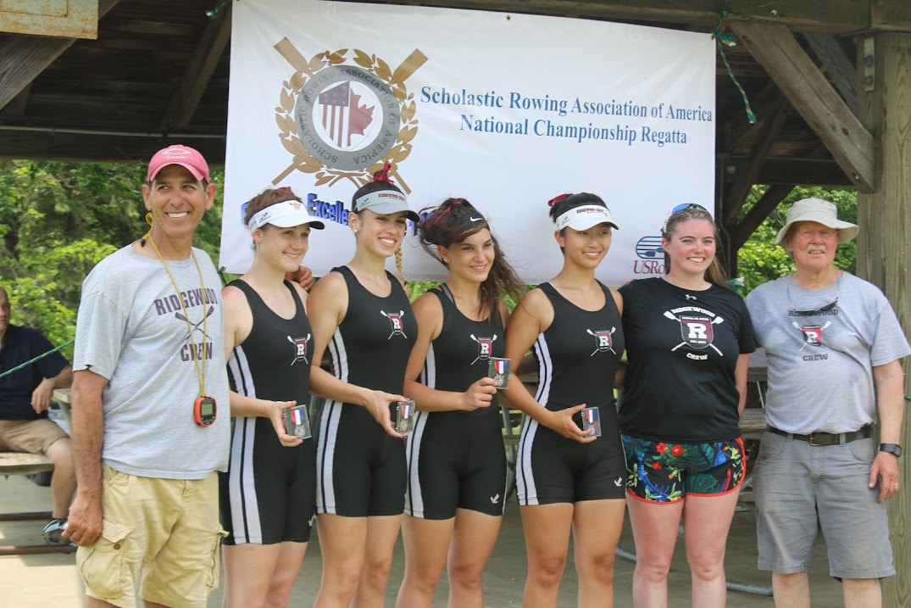
2 JV Girls 4x Accepting their Silver medals with Head Coach Boris Roque-Alvarez, Assistant Coaches Molly Dudrear and Bob O’Connor.

The individual results are as follows:

4th Place in the Heats Girls Ltwt Varsity 2x – D. Vij/S. Wong
4th Place in the Finals Girls JV 2x – H. Sisco/V. Lyakerman
5th Place in the Heats Girls Freshman 8+ – L. Glenning/S. Corcoran/S. Shah/S. Kornemann/S. Kahn/D. Guemeryl/E. Dowd/E. Howard/V. Krivor (Cox)
5th place in the Finals Girls Freshman 4x – C. Villemoes/E. Galbraith/I. Lee/L. Riedel
Silver Medal Winners Girls JV 4x – A. Soderlund/V. Hoy/L. Sudol/N. Kye
Gold Medal Winners Boys JV 4x – T. Montgomery/G. Martinez/M. Lepis/D. Park/
5rd Place in the Semi-Finals Boys JV 8+ – D. Yang/J. Andrews/E. Galbraith/Y. Choi/D. Joseph/K. Shattuck/J. Hida/T. Woods/D. Lerner (Cox)
4th Place in the Heats Boys Ltwt Varsity 4x – T. Reinsdorf/T. Lowicki/M. Carmona/F. Orlando

Head Coach Boris Roque-Alvarez and assistant coaches Molly Dudrear and Bob O’Connor we proud of the whole team’s efforts this season and elated over these results.

Ridgewood Crew is accepting new athlete members. All interested parties should register for the Learn To Row Program.

Website info: http://www.ridgewoodcrew.com/programs--practice-schedule.html

LTR online registration sign up form: https://forms.gle/fTqFkrwZPswgHJDE8

Still wondering about the sport? Join Ridgewood Crew for National Learn to Row Day Saturday, June 1 from 10 to 2 at Van Neste Memorial Park. Rowing is a terrific sport for all ages. Stop by to learn the basics and take a spin on an ergometer.

About Ridgewood Crew
Ridgewood Crew not only introduces participants to basic and advanced rowing techniques, but also instills and promotes character values including discipline, focus, teamwork and sportsmanship. Ridgewood Crew rowers are challenged individually and as a team. The philosophy of Ridgewood Crew is to elevate each athlete to the status of MVP. By doing so, we believe that a team of young leaders emerges. These leaders not only make fast boats, but also significant contributions toward their individual pursuits. Founded in 2004, the team rows on the Passaic River in northern NJ and competes in the sport’s premier regattas held throughout the Northeast.
In the program's short history, our youth, board and parent volunteers have moved Ridgewood Crew forward by leaps and bounds. That success is represented by the widespread individual and team achievements of each of the student-athletes on the roster. To facilitate that success, Ridgewood Crew continues to make investments in coaching and new equipment. The coaching staff is one of the most experienced in program history.
Ridgewood Crew athletes compete in the Philly Flicks on the Schuylkill River as well as at the highly competitive SRAA Nationals, Stotesbury Cup Regatta, Philadelphia City Championships, Passaic River Northern NJ Championships and Garden State Championships. Additionally, the team's overall performance continues to attract interest from top rowing colleges and universities including: Bucknell, Boston College, Boston University, Columbia University, Drexel, Duke, Fairfield, Fordham, George Mason, Georgetown, Harvard, Holy Cross, Lehigh, Marist, Notre Dame, Purdue, Syracuse, Trinity College, University of Delaware, University of North Carolina, University of Wisconsin, Williams, and others.
Ridgewood Crew offers Learn-To-Row and various development programs throughout the year for students as young as 7th grade to experience what Crew is all about. Come row with us!
For more information, to support or join the team, contact Ridgewood Crew at http://www.ridgewoodcrew.com and on Facebook at Ridgewood Crew!

###

