News for Immediate Release

Contact: Stacey Kliesch

201.655.4032

staceykliesch@gmail.com

Ridgewood Crew Makes Impressive Show with Gold, Silver and Bronze at the Stotesbury Cup Regatta!

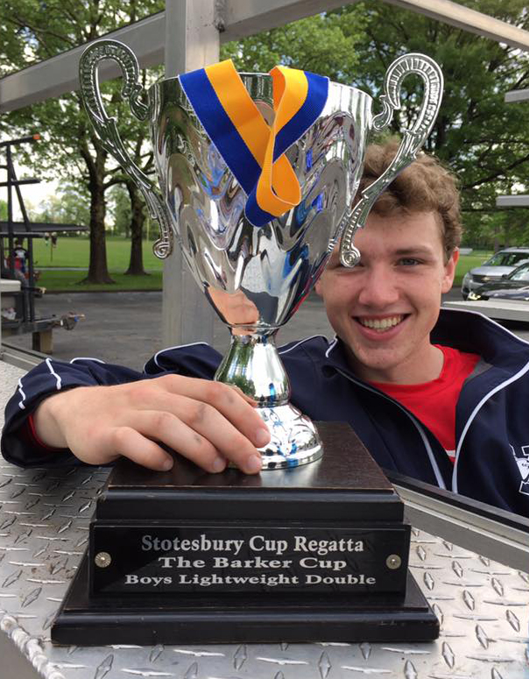

Gold Medalist Joseph O’Keefe. Photo by Jeanne Johnson.

Pennsauken, New Jersey, May 18-19, 2018 – The 92nd Stotesbury Cup Regatta was held on the Cooper River this year, a decision made by the Schuylkill Navy’s Regatta Leadership Team due to the excessive rainfall and potentially dangerous conditions in Philadelphia. One hundred and ninety-six clubs gathered for what is now the largest high school rowing regatta in the world. Ridgewood sent 14 crews to compete in a selection from 31 championship events, against exceptionally fine crews from all parts of the United States and Canada.

At the end of the qualifying heats, Ridgewood had 5 boats advancing to finals. Both the Girls Senior Double and the Girls Freshman Quad finished in fifth place overall.

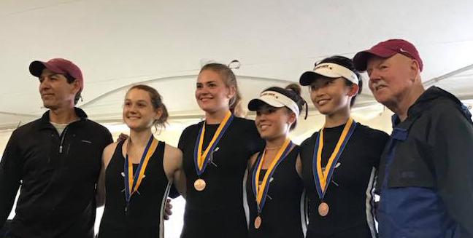

The Girls Junior Varsity Quad, rowed by Anna Soderlund, Hollis Sisco, Alexis Liu and Nicole Kye trimmed one minute, 16.120 seconds from their time to finish in third place behind E.L. Crossley and Conestoga. The medalists are shown here with Coaches Boris Roque-Alvarez and Bob O’Conner. Photo by Jeff Johnson.
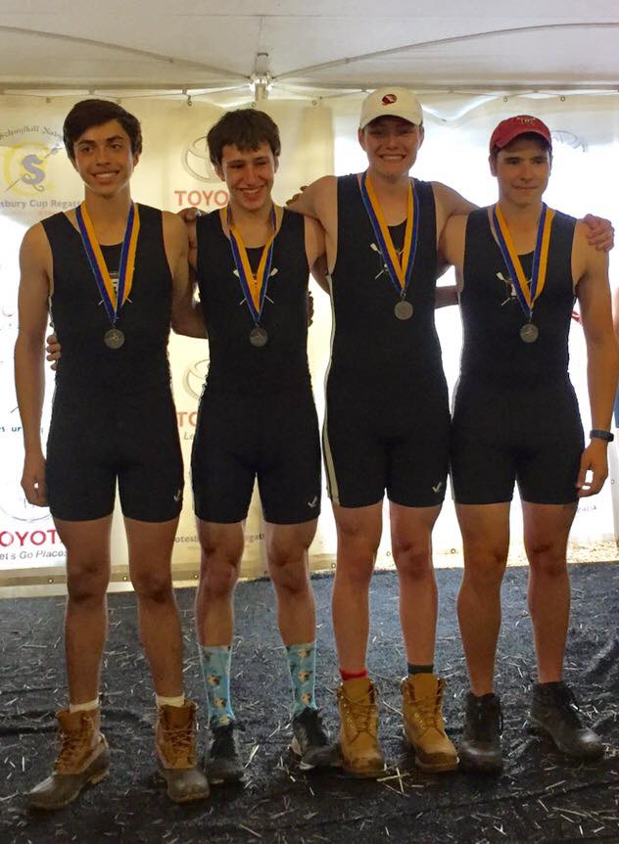

Second place was awarded to the Boys Junior Quad, rowed by Sebastian Rivero, Tom Montgomery, Drew Johnson, and Alex Melarti, finishing behind Saratoga after cutting 49.360 seconds from their time. Photo by Jeanne Johnson.
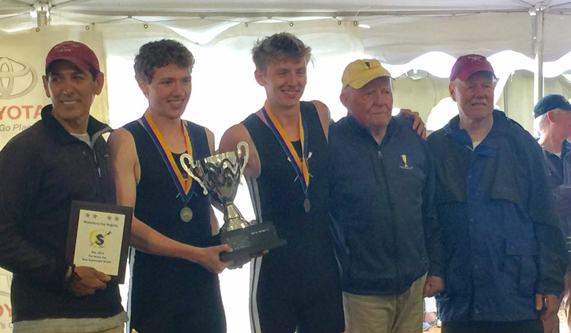

Crossing the finish line far ahead of the pack, Spencer Campbell and Joe O’Keefe of the Boys Lightweight Double slashed their time by one minute 25.4 seconds to take the gold. The champions were presented with The Barker Cup by Mr. Jim Barker, in the yellow cap, with Coaches Boris Roque-Alvarez and Bob O’Conner. Photo by Jeanne Johnson.

The Barker Cup is named in honor of the Barker family and their involvement in rowing. The trophy was donated by Jim Barker, retired head coach at The Haverford School. The trophy symbolizes Jim’s love of sculling and good sportsmanship. Jim began rowing in high school to prepare for football. He was in the Olympic trials and won Nationals as a single sculler. His sons and grandsons have also followed in the sport. Jim Barker has been involved in rowing for more than 50 years.

Ridgewood Crew Athletes continue to train in preparation for eleven boats to compete over Memorial Day Weekend on the Cooper River in the Scholastic Rowing Association National Regatta. Following that, four boats will be traveling to Lake Natoma in Gold River, California for the 2018 USRowing Youth National Championships presented by Rancho Cordova Travel and Tourism on June 8-10, 2018.

About Ridgewood Crew
Ridgewood Crew not only introduces participants to basic and advanced rowing techniques, but also instills and promotes character values including discipline, focus, teamwork and sportsmanship. Ridgewood Crew rowers are challenged individually and as a team. The philosophy of Ridgewood Crew is to elevate each athlete to the status of MVP. By doing so, we believe that a team of young leaders emerges. These leaders not only make fast boats, but also significant contributions toward their individual pursuits.
Ridgewood Crew introduces Ridgewood, NJ high school-aged youth to the traditions, athleticism, sportsmanship, techniques and camaraderie of the sport of rowing. Founded in 2004, the team rows on the Passaic River in northern NJ and competes in the sport’s premier regattas held throughout the Northeast.
In the program's short history, our youth, board and parent volunteers have moved Ridgewood Crew forward by leaps and bounds. That success is represented by the widespread individual and team achievements of each of the student-athletes on the roster. To facilitate that success, Ridgewood Crew continues to make investments in coaching and new equipment. The coaching staff is one of the most experienced in program history.
Ridgewood Crew athletes compete in the Philly Flicks on the Schuylkill River as well as at the highly competitive SRAA Nationals, Stotesbury Cup Regatta, Philadelphia City Championships, Passaic River Northern NJ Championships and Garden State Championships. Additionally, the team's overall performance continues to attract interest from top rowing colleges and universities including: Bucknell, Boston College, Boston University, Columbia University, Drexel, Duke, Fairfield, Fordham, George Mason, Georgetown, Harvard, Holy Cross, Lehigh, Marist, Notre Dame, Syracuse, Trinity College, University of Delaware, Williams, and others. The program also celebrated its first female athlete to receive a full, four-year rowing scholarship.
Ridgewood Crew offers several ways for you to experience our mission: join the team, volunteer or donate. Student athlete programs being with Learn-To-Row for middle school schoolers.
For more information, to support of join the team, contact Ridgewood at http://www.ridgewoodcrew.com
###

