News for Immediate Release

Contact: Stacey Kliesch

201.655.4032

staceykliesch@gmail.com

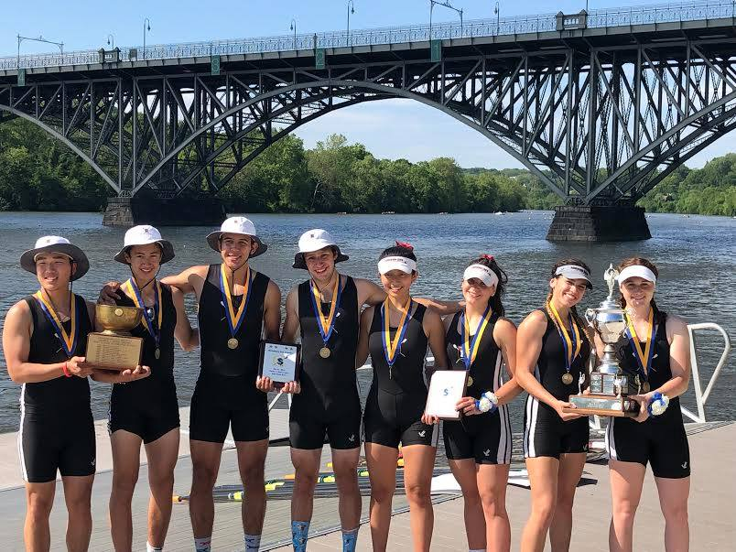
1Junior Boys and Girls Quads Each Win GOLD at the 2019 Stotesbury Cup Regatta!

Outstanding Results for Ridgewood Crew with Two Gold Medals, a Silver and Bronze at the Stotesbury Cup Regatta!

Philadelphia, Pennsylvania, May 17-18, 2019 – The 93nd Stotesbury Cup Regatta hosted by Schuylkill Navy of Philadelphia took place this past weekend. One hundred and eighty-five clubs gathered at the Schuylkill River for what is now the largest high school rowing regatta in the world. Ridgewood sent 14 crews to compete in a selection from 31 championship events, against exceptionally fine crews from all parts of the United States and Canada.

Overall, Ridgewood came in sixth place in team points, second place in sculling crews and first place over all NY/NJ teams at the event.

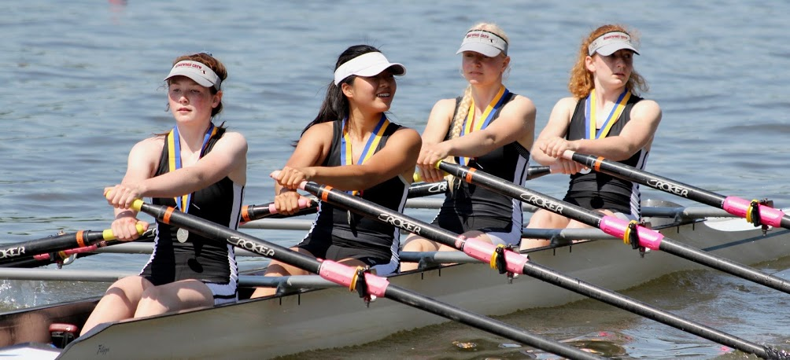
2Freshman Girls Quad Takes the Silver Medal! Photo by Mark Riedel

The impressive individual results are as follows:

4th Place in the Finals Girls Junior Double – H. Sisco/V. Lyakerman
5th Place in the Semi-Finals Boys Junior Double – K. Okamura/F. Orlando
25th Place in the Heats Girls Freshman Eight – L. Glenning/S. Corcoran/S. Shah/S. Kornemann/S. Kahn/D. Guemeryl/E. Dowd/E. Howard/V. Krivor (Cox)
4th Place in the Semi-Finals Girls Ltwt Double – S. Wong/A. Liu
44th Place in the Heats Boys Junior Four – J. LaFrance/C. Nuzzolo/J. Scanlon/J. Warren/M. Lee (Cox)
17th Place in the Heats Boys Ltwt Double – T. Lowicki/M. Carmona
6th Place in the Finals Boys Freshman Quad – B. Lintner/T. Gammer/C. D’Arpa/P. Joseph
3rd Place in the Semi-Finals Boys Junior Eight – D. Yang/J. Andrews/E. Galbraith/Y. Choi/D. Joseph/K. Shattuck/J. Hida/T. Woods/D. Lerner (Cox)
Silver Medal Winners Girls Freshman Quad – C. Villemoes/E. Galbraith/I. Lee/L. Riedel
Gold Medal Winners Boys Junior Quad – T. Montgomery/G. Martinez/M. Lepis/D. Park/
Gold Medal Winners Girls Junior Quad – a. Soderlund/V. Hoy/L. Sudol/N. Kye/

21st Place in the Heats Boys Senior Double – F. Hamilton/T. Reinsdorf
6th Place in the Semi-Finals Girls Senior Quad – D. Vij/P. Kliesch/K. Rahnefeld/S. Lee
Bronze Medal Winners Boys Senior Quad – D. Johnson/A. Saladucha/A. Melarti/S. Rivero

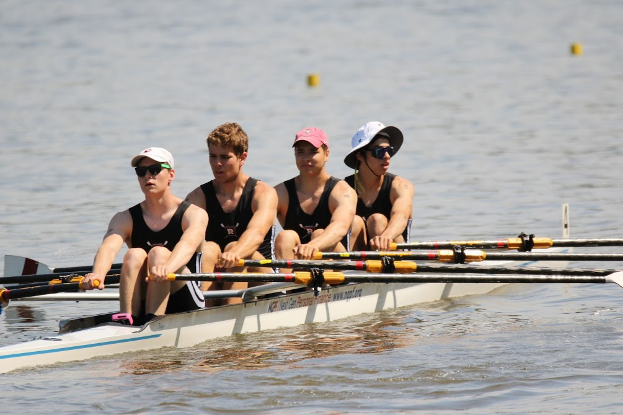
3Bronze Medal Winners Boys Senior Quad. Photo by Edward Hida

According to RegattaCentral.com, The Stotesbury Cup Regatta has been held continuously since 1927. Edward T. Stotesbury, a local philanthropist, was urged by members of the Philadelphia rowing community to underwrite the cost of an award to serve as the ultimate goal for scholastic rowing: winning the Boys Senior Eight race. The first Stotesbury Cup was won by Philadelphia’s West Catholic High School.
Women began rowing in the Stotesbury Cup Regatta in 1974 with the Girls’ Senior Eight competition. The first winner of that race was St. Andrew’s School of Delaware. Today young women make up more than 50 percent of the rowers at the regatta.
Over the years, races and trophies have been added to the regatta, culminating in today’s 31 championship events. What began as a local Philadelphia "Cup Race" quickly evolved into a full-fledged regatta that today endures as the largest high school rowing regatta in the world.
Exceptionally fine crews from all part of the United States and Canada travel to the Schuylkill River in Philadelphia to participate in the Stotesbury Cup Regatta. Over 5,000 competitors meet at the Athletes Village to experience both the spirit of rowing competition as well as the physical challenge of pitting themselves against the very finest crews rowing at the high school level. Their achievements draw a crowd of nearly 10,000 spectators.

Ridgewood Crew Athletes continue to train in preparation for the 2019 Scholastic Rowing Association of America National Championship Regatta on May 24 and 25 at Lake Dillon in Nashport, OH. This year, eight boats are attending.
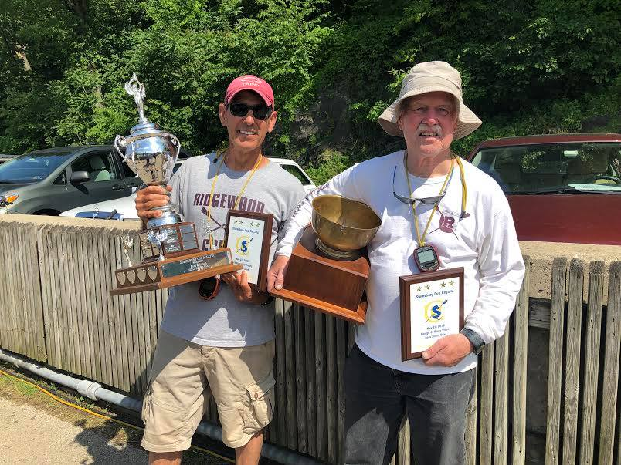
4 Proud Coaches Boris L. Roque Alvarez and Bob O'Connor

About Ridgewood Crew
Ridgewood Crew not only introduces participants to basic and advanced rowing techniques, but also instills and promotes character values including discipline, focus, teamwork and sportsmanship. Ridgewood Crew rowers are challenged individually and as a team. The philosophy of Ridgewood Crew is to elevate each athlete to the status of MVP. By doing so, we believe that a team of young leaders emerges. These leaders not only make fast boats, but also significant contributions toward their individual pursuits. Founded in 2004, the team rows on the Passaic River in northern NJ and competes in the sport’s premier regattas held throughout the Northeast.
In the program's short history, our youth, board and parent volunteers have moved Ridgewood Crew forward by leaps and bounds. That success is represented by the widespread individual and team achievements of each of the student-athletes on the roster. To facilitate that success, Ridgewood Crew continues to make investments in coaching and new equipment. The coaching staff is one of the most experienced in program history.
Ridgewood Crew athletes compete in the Philly Flicks on the Schuylkill River as well as at the highly competitive SRAA Nationals, Stotesbury Cup Regatta, Philadelphia City Championships, Passaic River Northern NJ Championships and Garden State Championships. Additionally, the team's overall performance continues to attract interest from top rowing colleges and universities including: Bucknell, Boston College, Boston University, Columbia University, Drexel, Duke, Fairfield, Fordham, George Mason, Georgetown, Harvard, Holy Cross, Lehigh, Marist, Notre Dame, Purdue, Syracuse, Trinity College, University of Delaware, University of North Carolina, University of Wisconsin, Williams, and others.
Ridgewood Crew offers Learn-To-Row and various development programs throughout the year for students as young as 7th grade to experience what Crew is all about. Come row with us!
For more information, to support or join the team, contact Ridgewood Crew at http://www.ridgewoodcrew.com and on Facebook at Ridgewood Crew!

###

